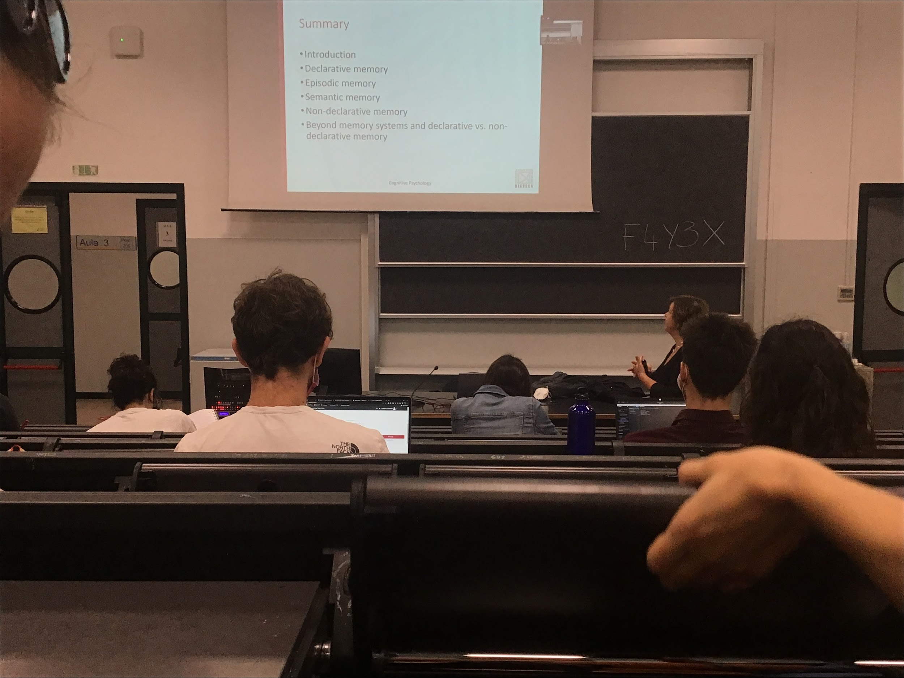

Contrary to the original idea of 3 memory stores (sensory, short time memory, long time memory). Each one of these memory store is complex and have different aspects

Long time memory is the store where we keep all the information learned in our lifetime

Different type of information stored in different areas of the brain

**Declarative memory**: explicit memory, what we can actually explicitly tell about what I know

In the declarative memory there are two main type of memory:

* **Semantic memory**: meaning, concept, schemas
* **Episodic memory**: related to a single moment

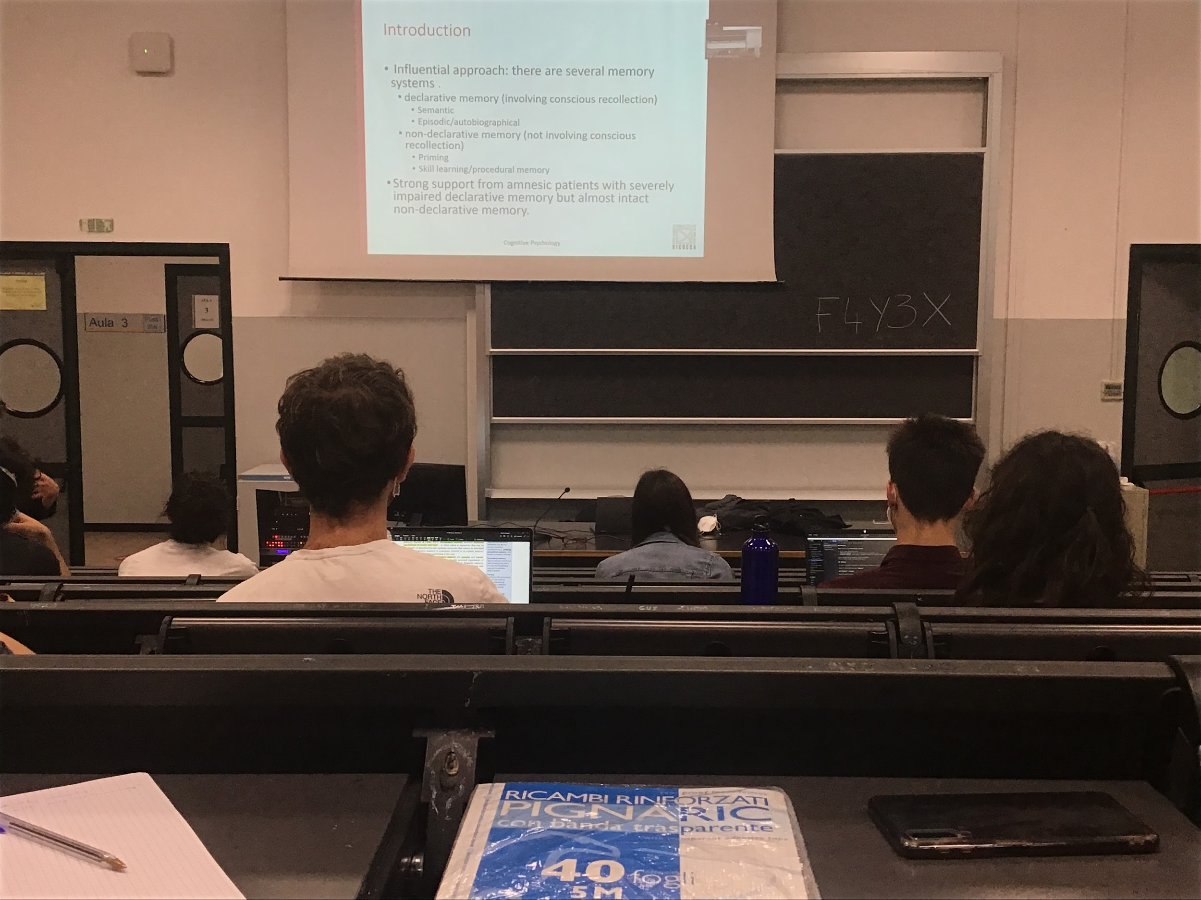

Long time memory divided in declarative memory and nondeclarative memory

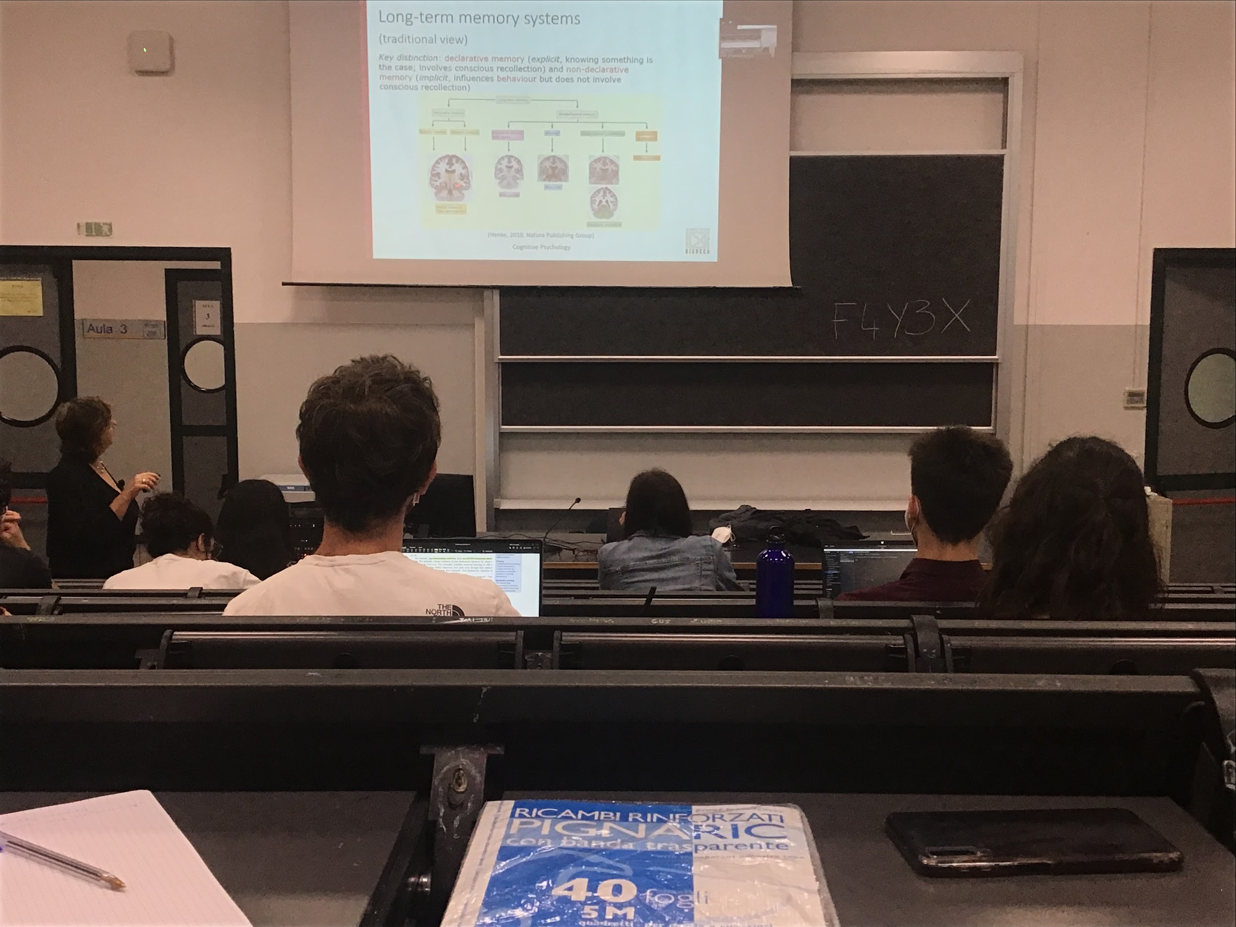

**Different type of memory activates different areas of the brain**

Long time memory is not just one store, different type of information are saved using different parts of our brain

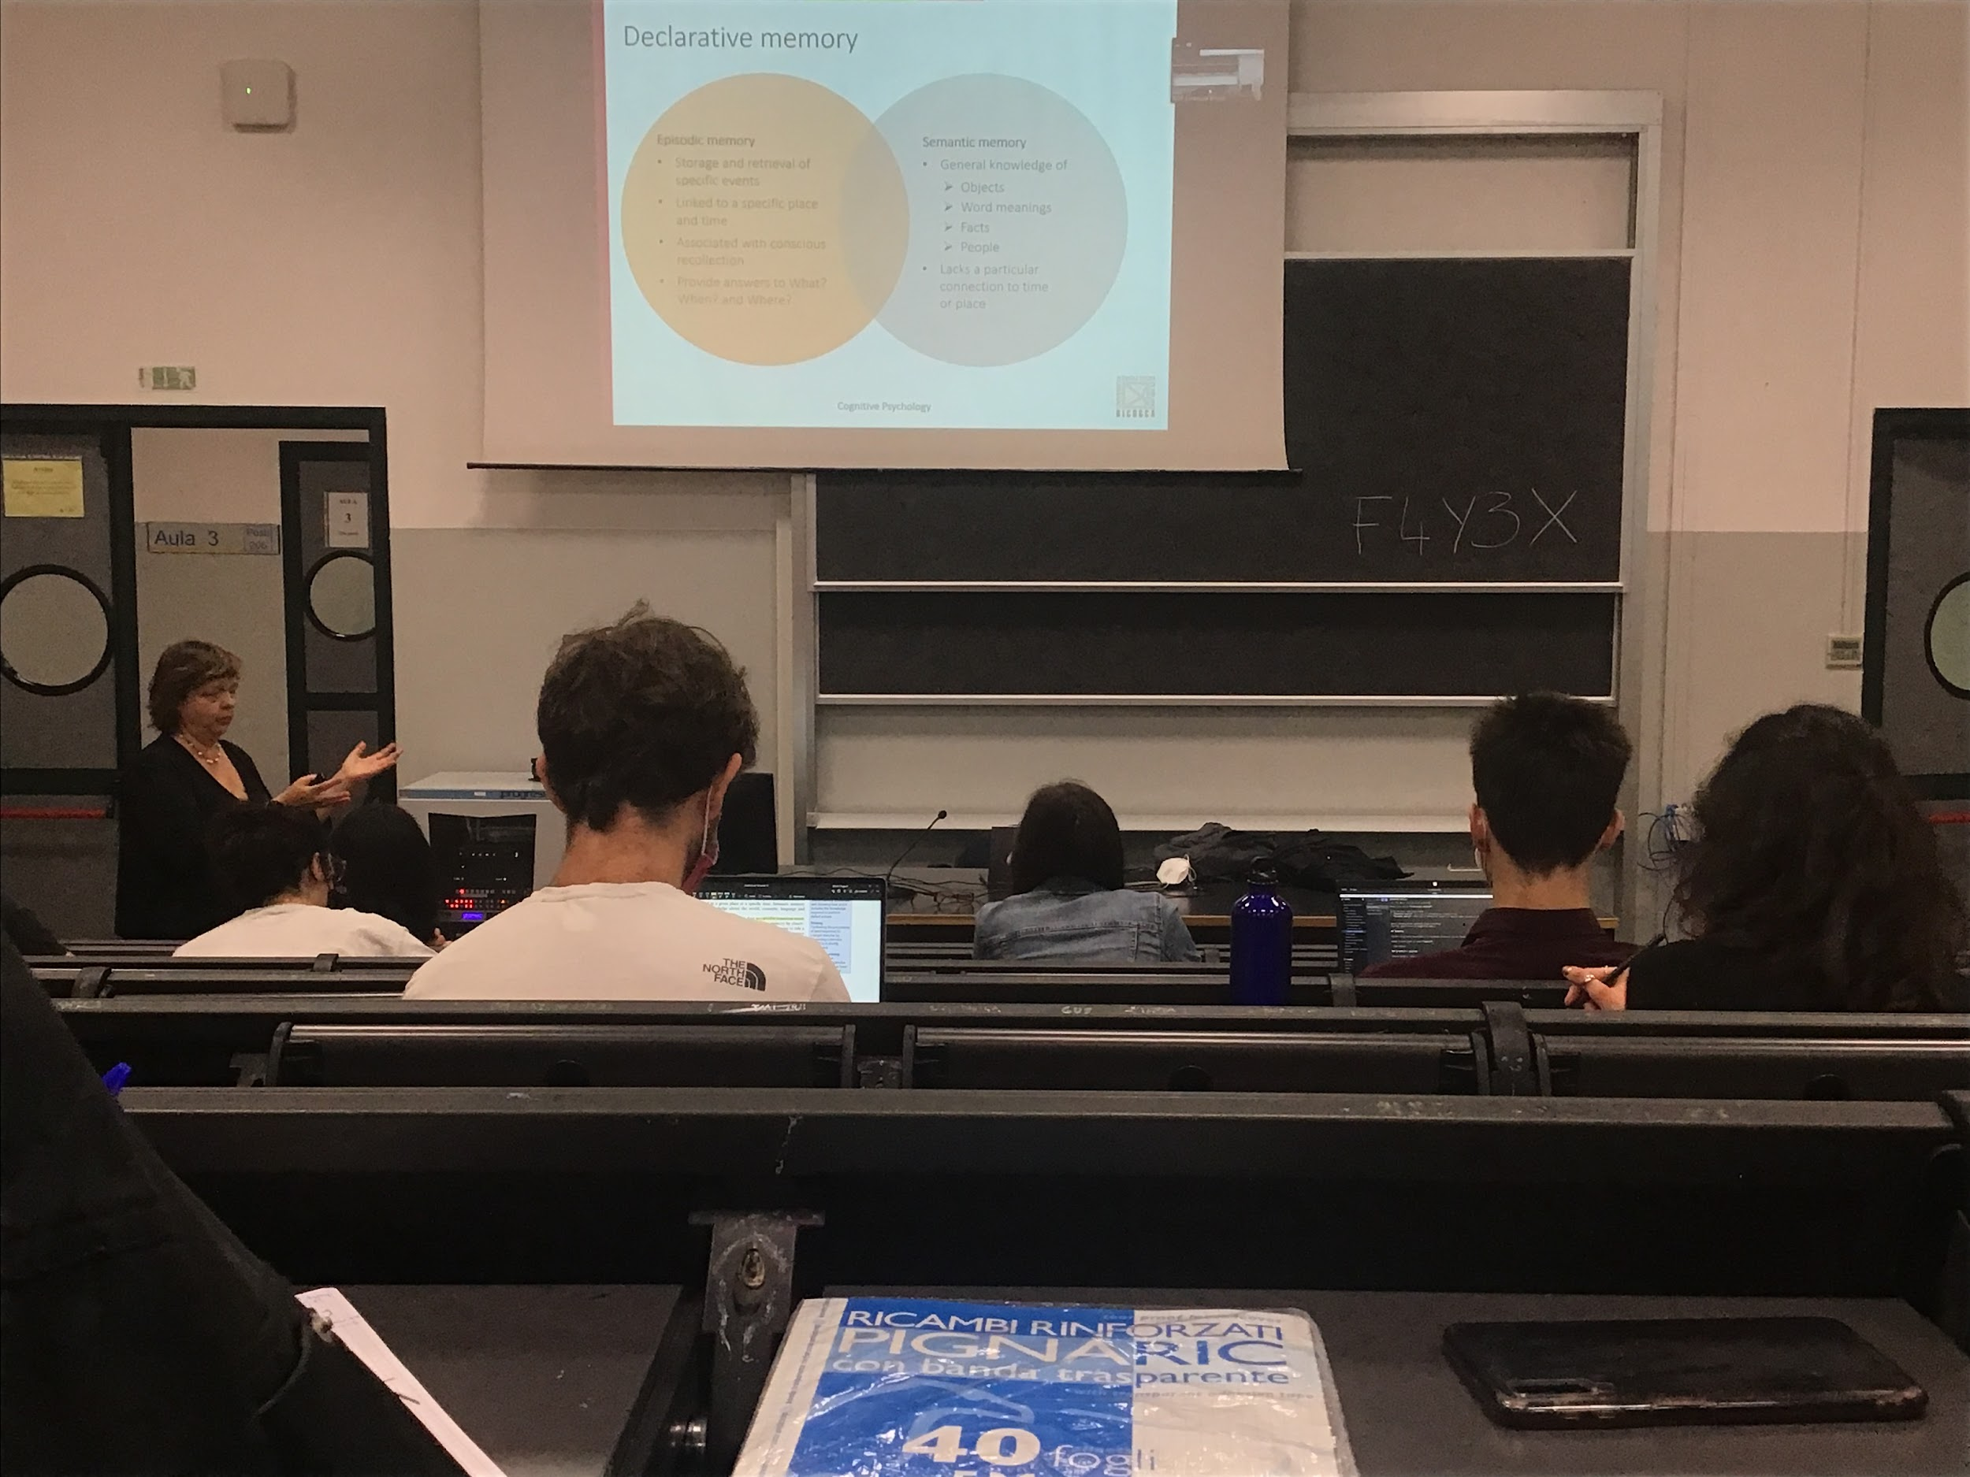

Differences between episodic or semantic memory

**Episodic memory**: episody (things that happens in our life) episodic memory contains information, specific events that happened in our life enable us to retrieve that information from our memory

Information linked to a specific time and place. Associated to conscious recollection you do actually remember what you did last night

The 3 W: can tell **What** happened, **When** happened and **Where** it happened, we can give information about all these different aspects

You can also remember something that happened to someone else

**Semantic memory**: our information knowledge of concepts about objects, about words meaning, facts and people. What I know is not associated with a time or a place where I learned that thing.

You know the president of USA but don’t know when or where you learned this information, lost the information about time and place

A lof information that we have that is fundamental for our interaction with the environment is store in semantic memory

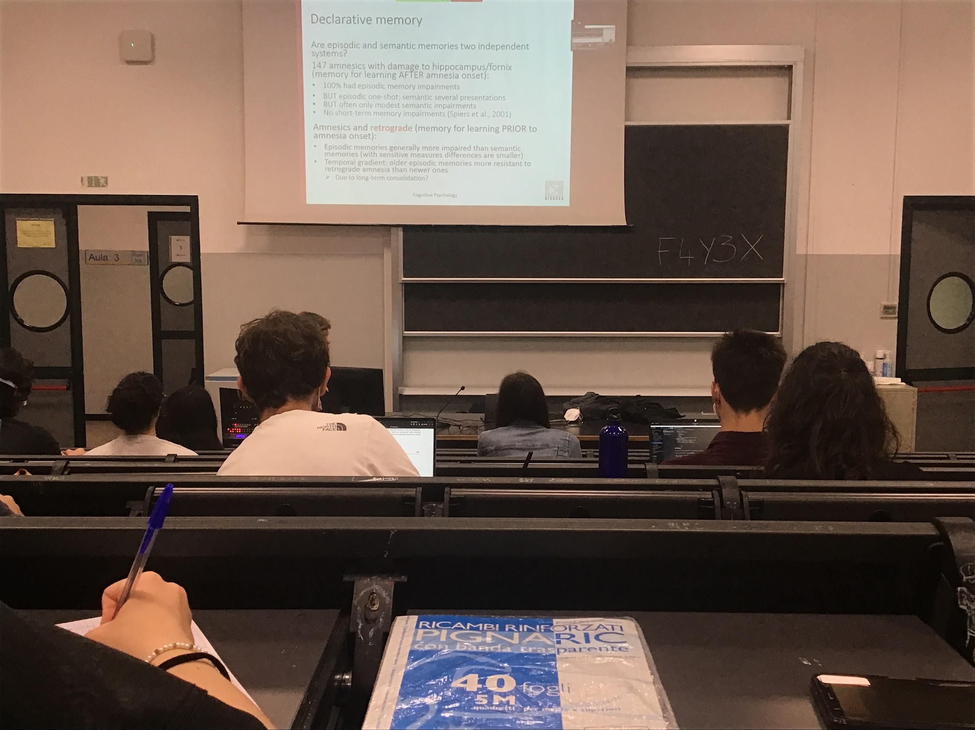

Why do we make this distinction between episodic and semantic memory? researchers have realised this because the informations are saved in different memory spaces. One can be problematic while the other is not.

Are these two systems (episodic and semantic) completely independent or there is interaction?

To tell that a system is independent: use neuropsychological data

Use neuropsychology to find double dissociation to test independence of episodic and semantic memory. Find a group of patients that have a problem with episodic memory and not with semantic, and another group that have problem with semantic but not with episodic memory

People who have problems with episodic memory are **amnesic** (lesions in the hippocampus). Most of the time they do not remember anything about episodes(episodic), but are still able to know the meaning of the words(semantic), speech…

Can not actually remember what happened last time but can talk in general about it. If you ask them *What did you eat last night?* they do not remember what they ate, but they can answer like *usually I eat past at night*. They know the question but the only problem they have is that they do not remember what exactly they ate last night. These people have problems with episodic memory.

Do remember semantics

In theory semantic memory could be build up of episodic memory

Amnesic patients that have regrade amnesia, still have the same situation:

* episodic memory more impaired than semantic memory
* temporal gradient: older the episodi is easier to remember

What the data show: there is a difference between episodic and semantic, but maybe semantic memory is stronger becomes comes out of consolidation

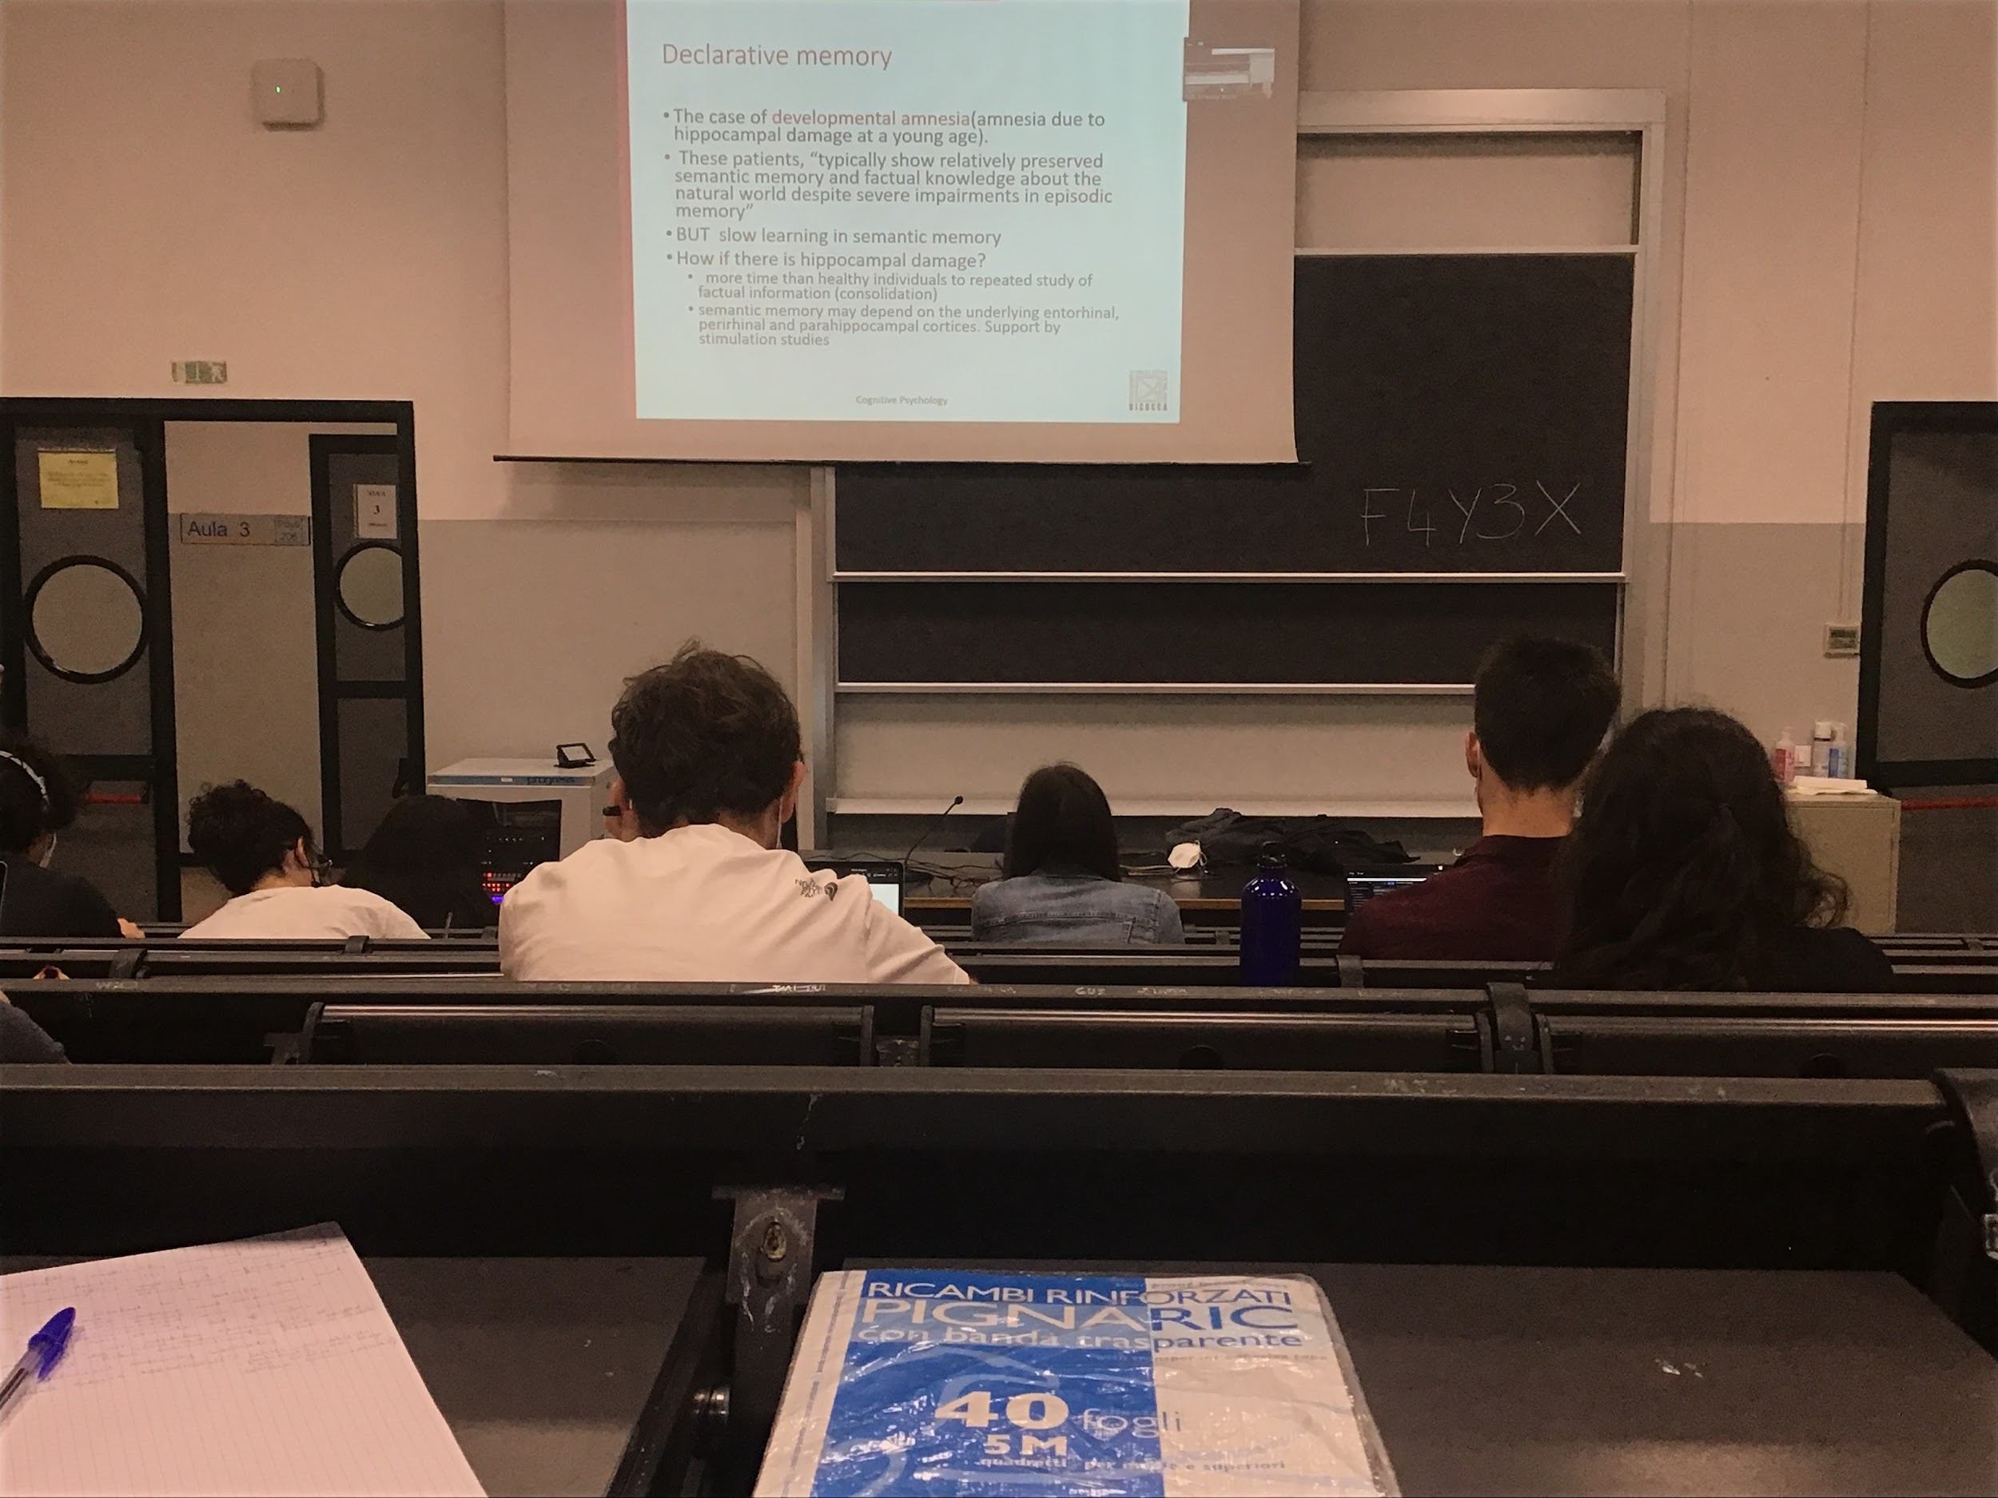

**Developmental amnesia**: not a problem that emerges because an accident, tumour… starts when people are very young and grows when they grow up

Ability to learn in semantic memory but slow compared to other people. Probably their residual ability comes from the fact that it is not only the hippocampus that helps learn new information but all the cortexes around the hippocampus too.

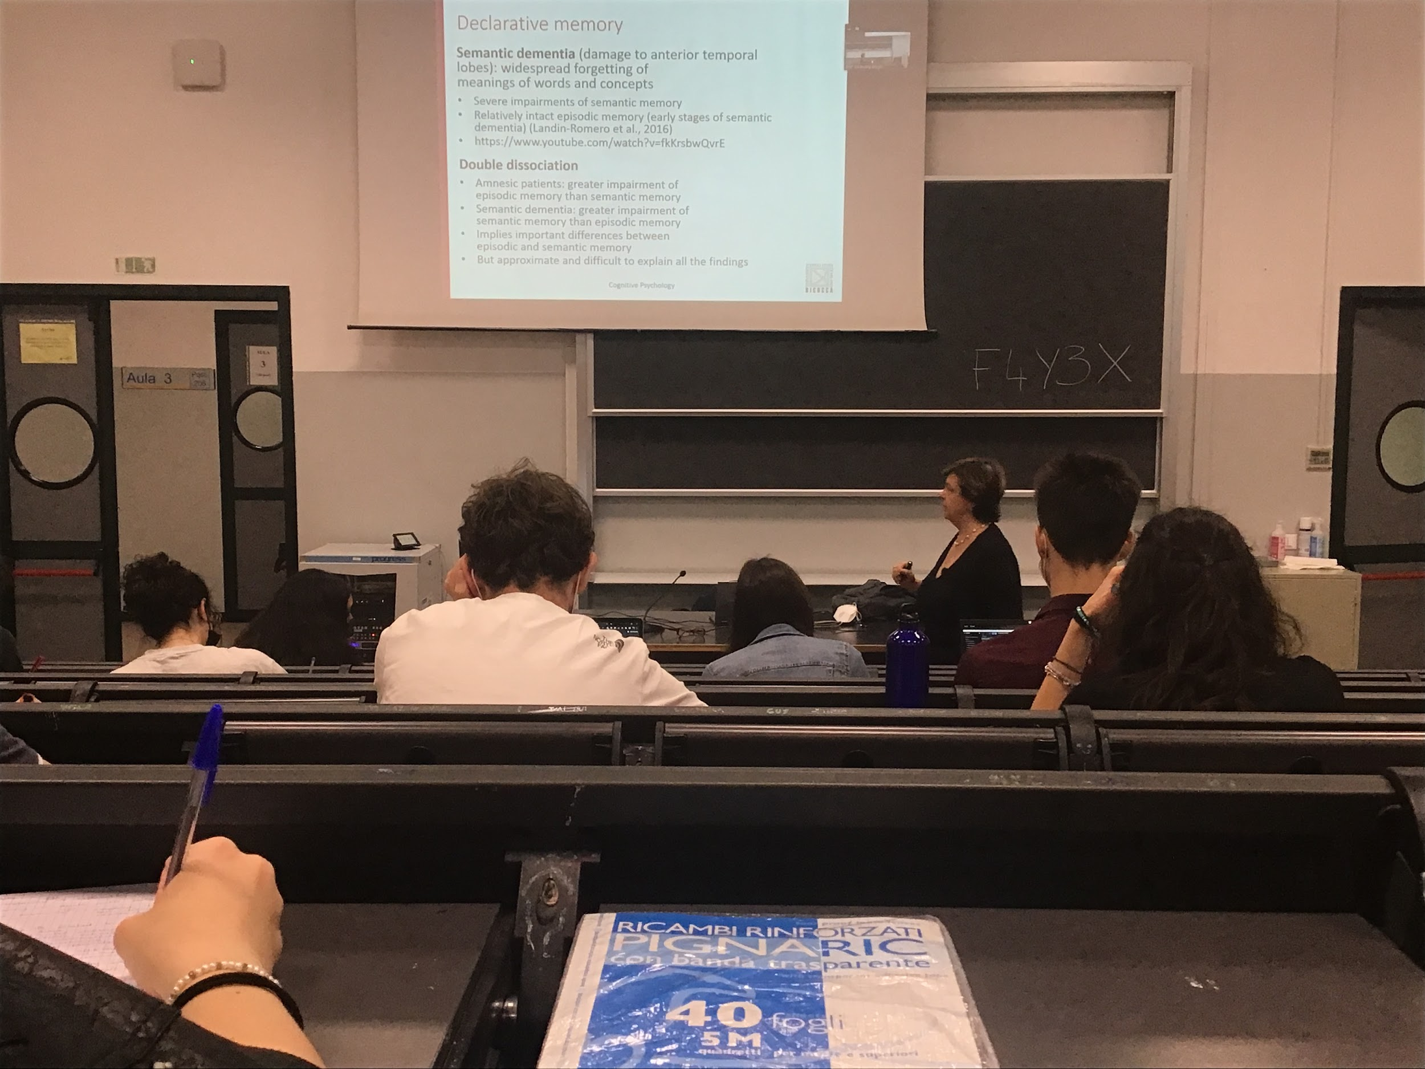

Double dissociation: need someone that still able to remember what happened in their life but not able to understand anymore the meaning of words

Semantic dementia, very strong impairment of semantic memory, they have spare episodic memory, do not understand anymore the words, difficult to tell me what you remember. Semantic memory is a selective impairment in early stages they are actually able to tell what happened yesterday night.

Semantic dementia Video ([Semantic dementia video](https://youtu.be/fkKrsbwQvrE)): lady with semantic dementia, words don’t come out, she uses a lot of words as placeholders for what she wants to say, in her mind she knows what she wants to say but the words don’t come out.

In semantic dementia is a select inability to extract semantic information from our memory, sometimes appears also with people with alzheimer

Slowly lose the ability to name objects and understand what they are

Slowly lose ability to access and use semantic memory

Semantic dementia: there is a double dissociation

* the amnesic people have greater impairment of episodic memory rather than semantic
* the semantic dementia: greater impairment of semantic memory rather than episodic

This **double dissociation implies that there is a difference between the two type of information that we store in our memory**

Not so clear cut

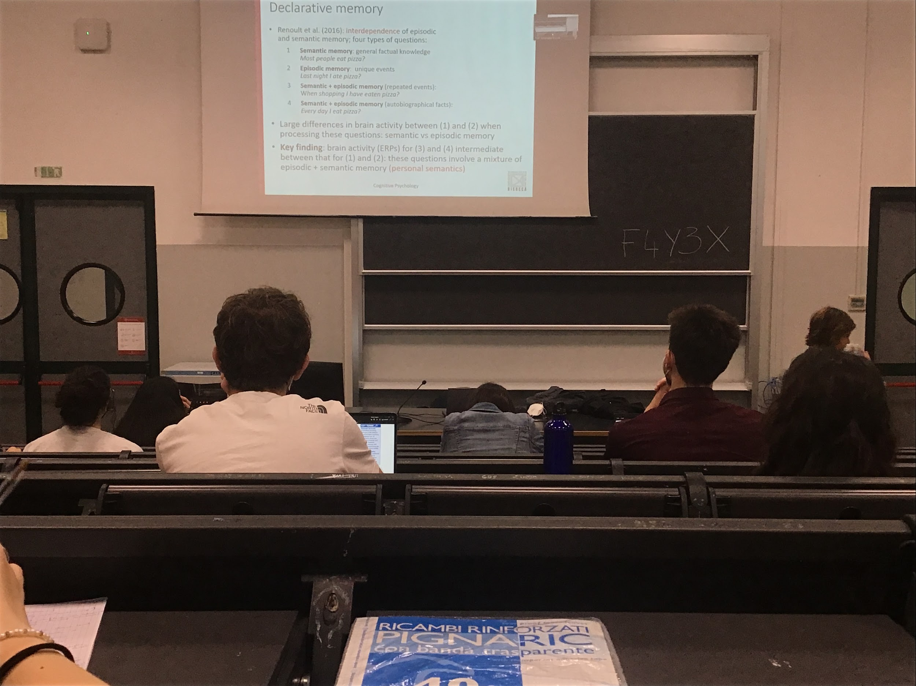

There is some kind of **interdependence**, connected with each other

**Experiment**: test interdependence by asking people different types of questions. Some question are semantic (general fact), some episodic (specific event) or a mix

1. Semantic memory: general factual knowledge *Most people eat pizza?*
2. Episodic memory: specific event *Last night you ate pizza?*
3. Semantic + episodic memory:
   1. Repeated events: *When shopping you ate pizza?*
   2. Autobiographical fact: *Every day you eat pizza?*

To see interconnection or interdependence this author look at the brain activation when I try to answer these questions

If there are two different systems, it should activate 2 different brain areas. While when answering semantic + episodic memory it should be a superposition of the two (if they are completely independent)

Large difference in brain activity, different brain areas that are active when you test simply pure semantic information or when you test pure episodic information

There is an intermediate activity, when you ask questions 3 and 4. There is actually some kind of itnerdencene (called personal semantic)

Not completely separate

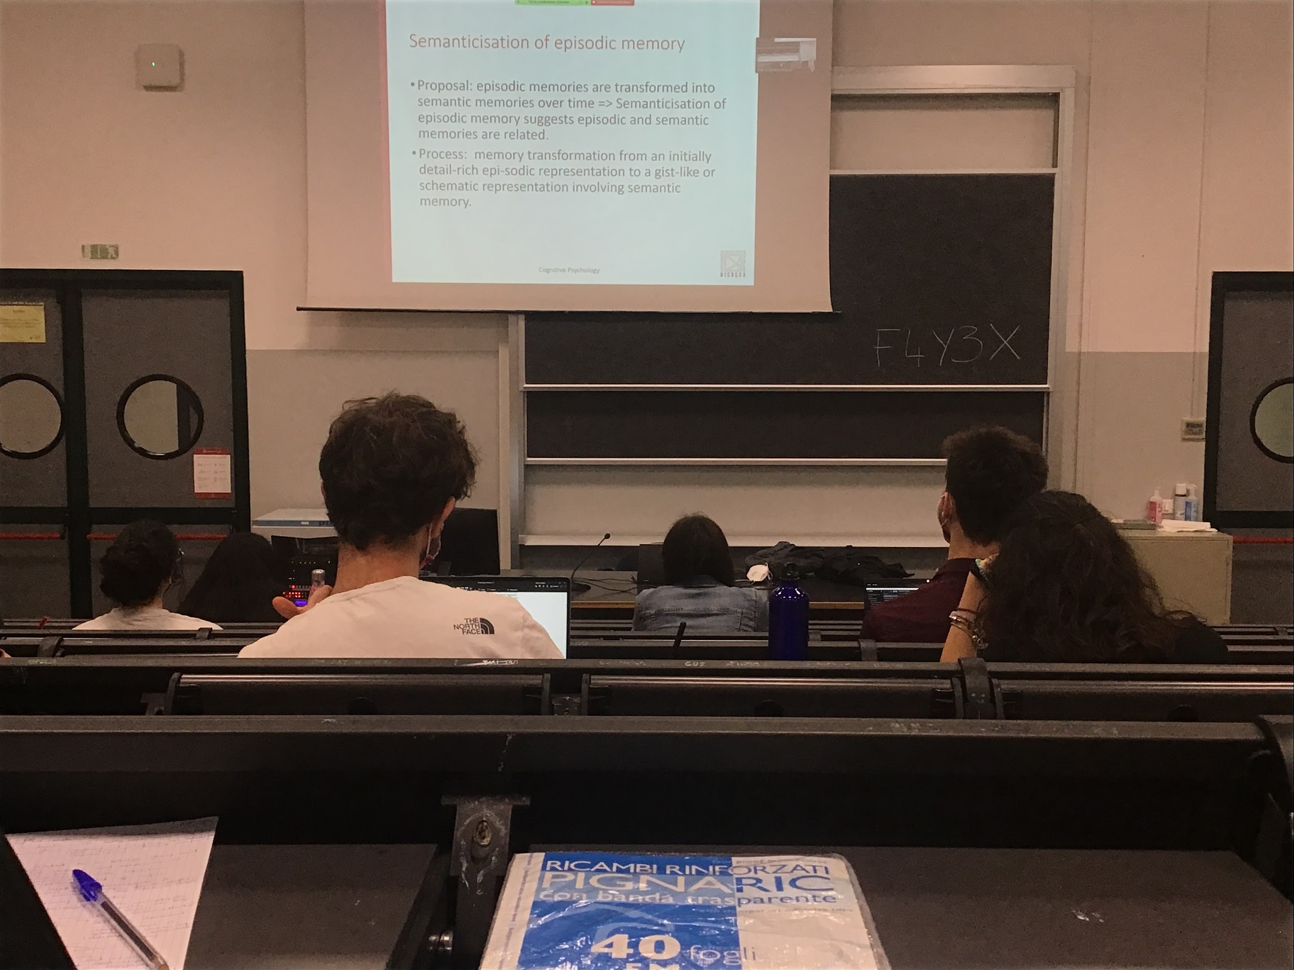

**Personal semantic: what is in a given moment episodic is transformed in semantic over time**, some kind of information at the beginning episodic event is maintained in memory with a lot of detail and slowly over time it transfer to semantic and loses details about time and place

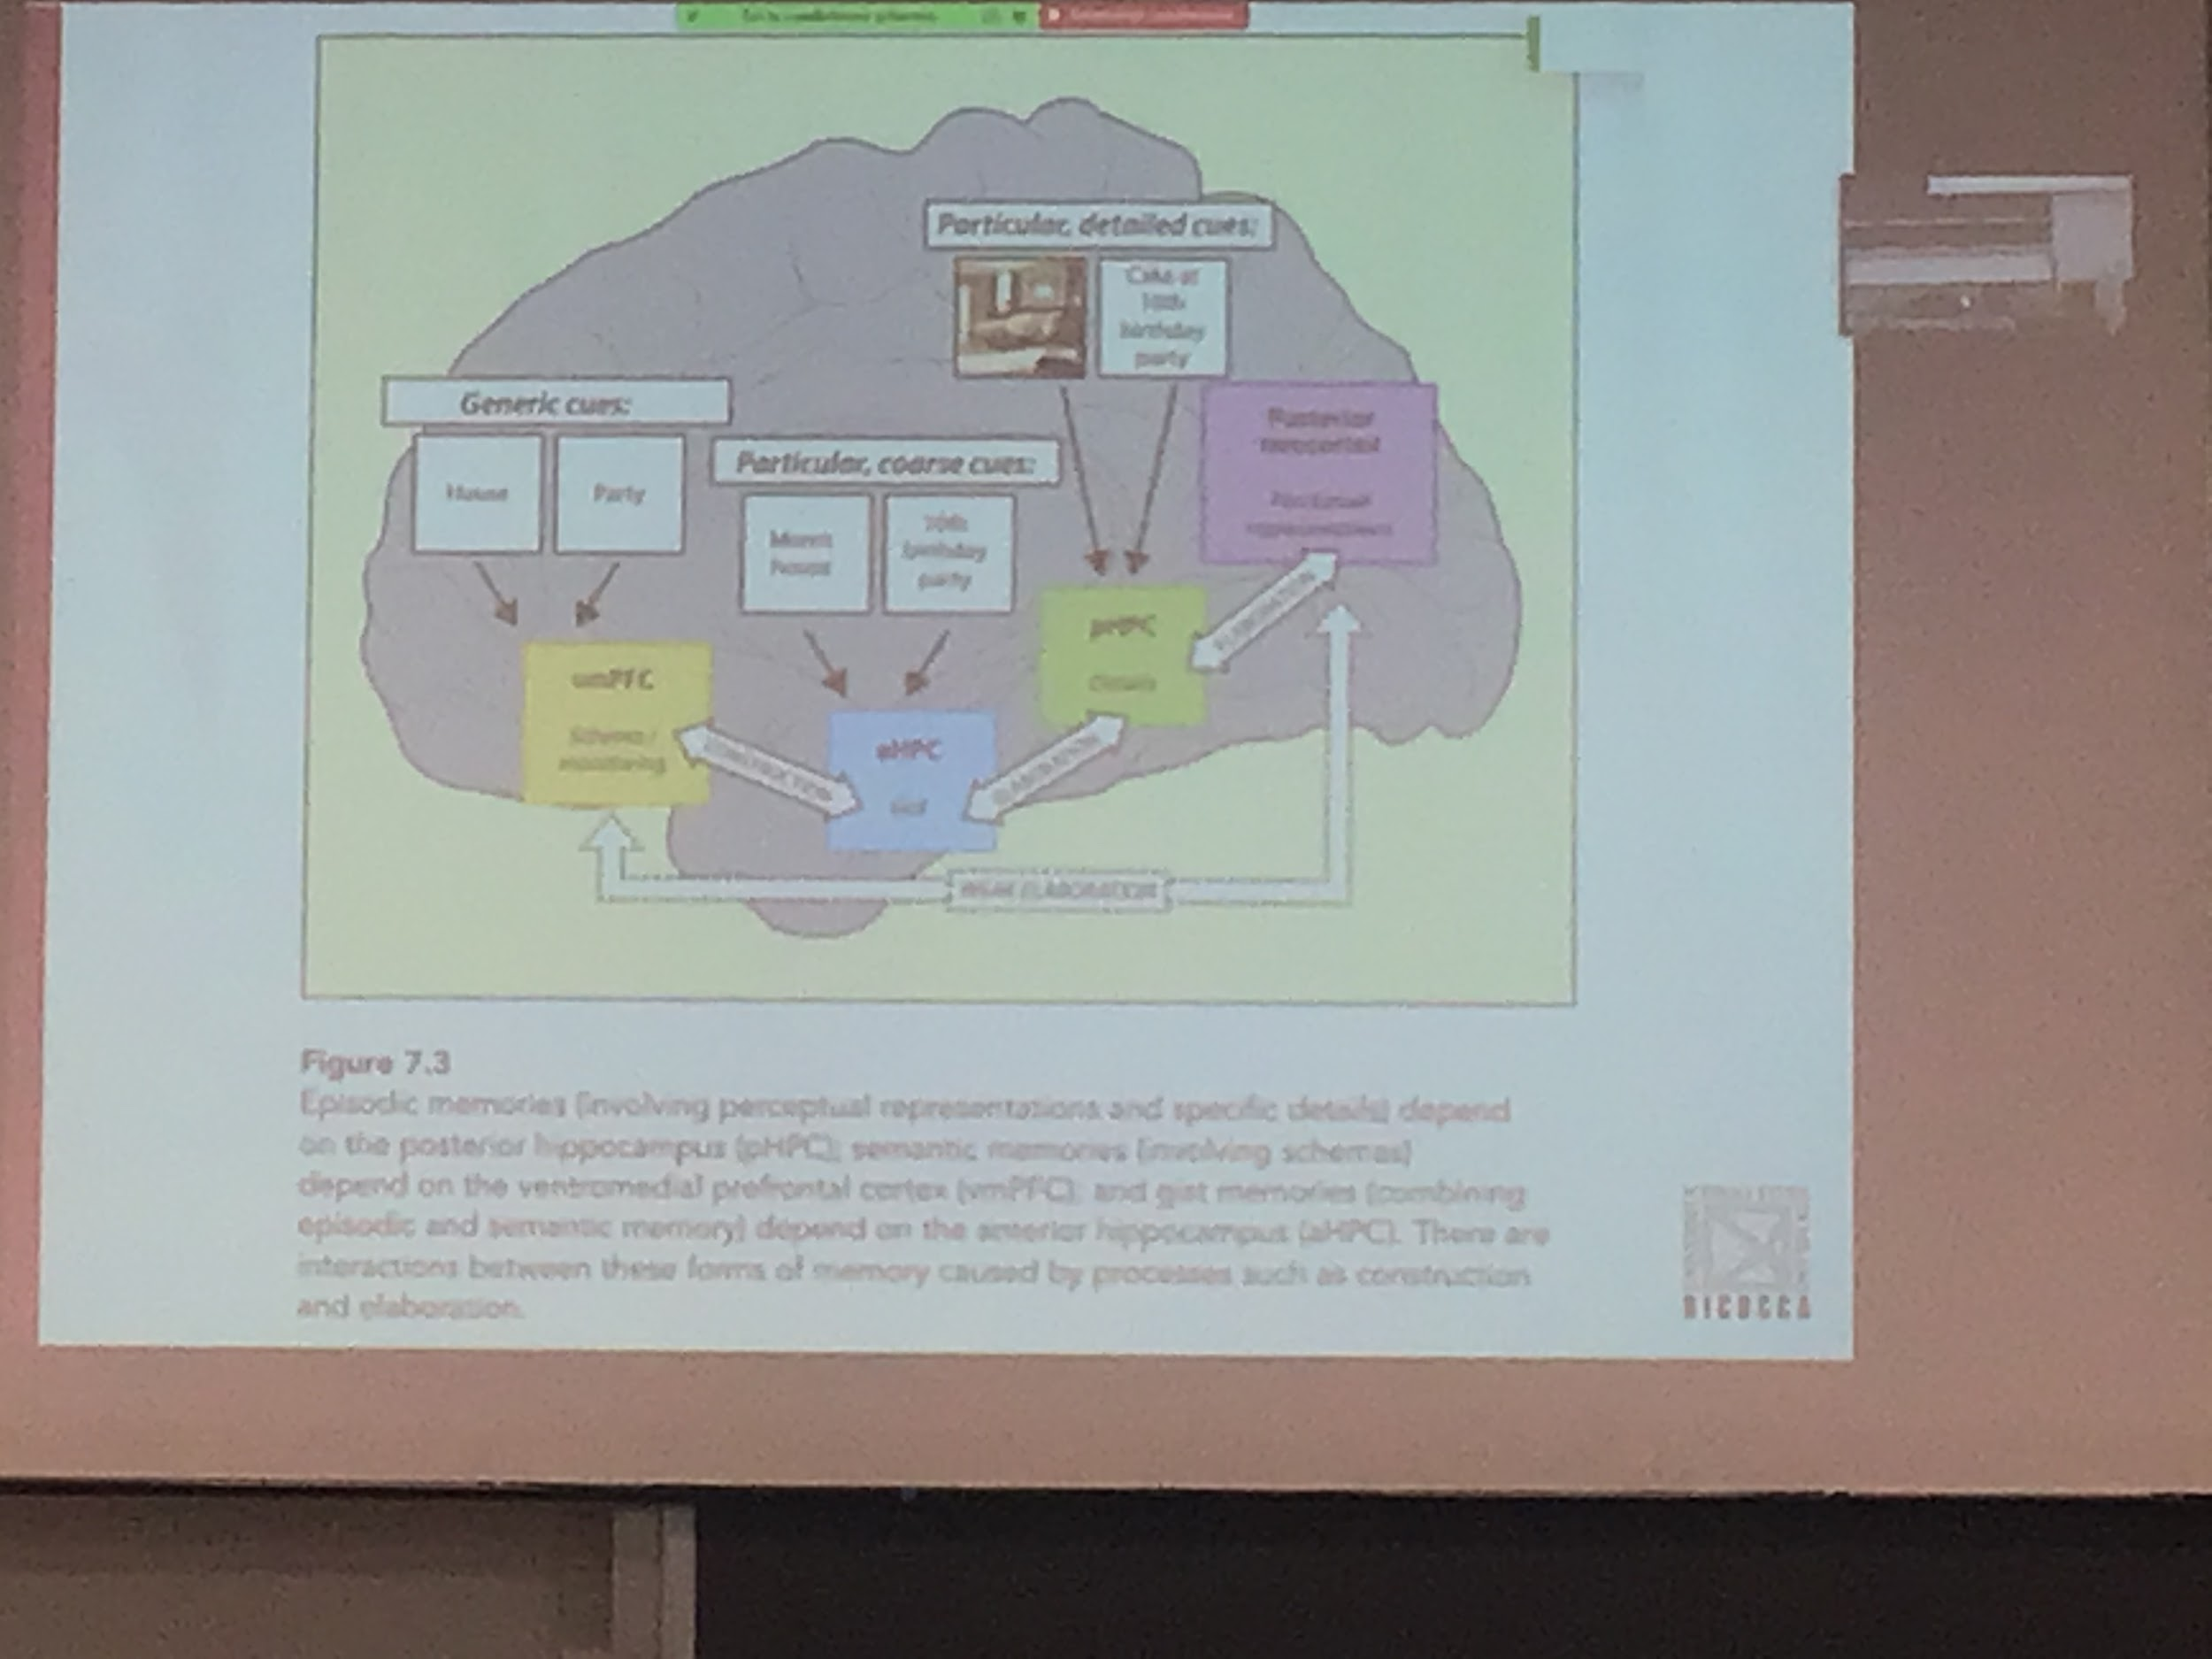

Semantic memory save general information about a given situation, saved in a different part of the brain

Areas when we save information a mixture of episodic and semantic

Interaction between all these type of memory but in some kind of way they are maintained independent

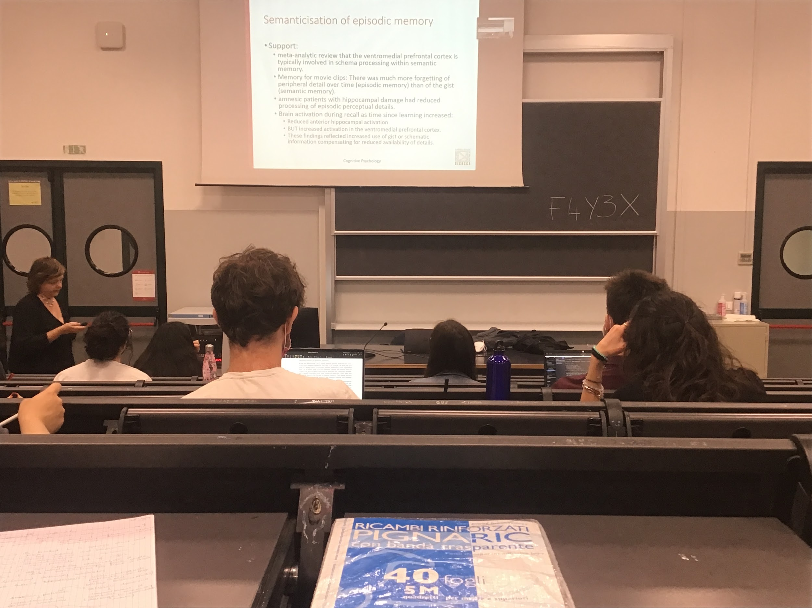

If you test memory for movie clips (show small clips of movies) I see that if I test you memory right after showing the clip, you remember a lot of details, over time you lose details and just remember what the clip was about

Support for this idea also comes from amnesic patients, unable to process details of the episodic information. The brain activity during recall shows that there is a shift in what types of areas are active

As time passes you lose activation in the anterior hippocampus and increase activation in the ventromedial prefrontal cortex (where semantic memory is)

Over time what is episodic loses detail, maintain some kind of basic information that we save in semantic memory

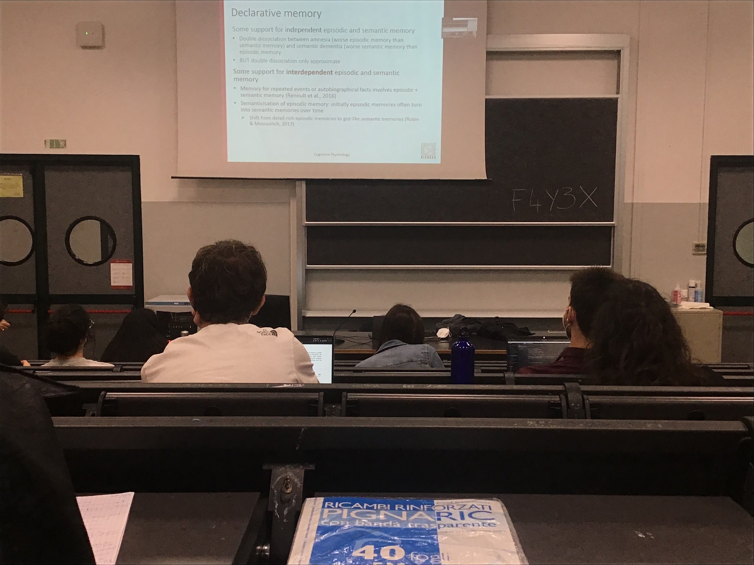

Some support for independent episodic and semantic memory

Some support for interdependent episodic and semantic memory

The double dissociation is approximate (not perfect)

There is a different activation when we try to test information combined episodic and semantic, the information is transfer from the episodic memory to the semantic memory

## Episodic memory

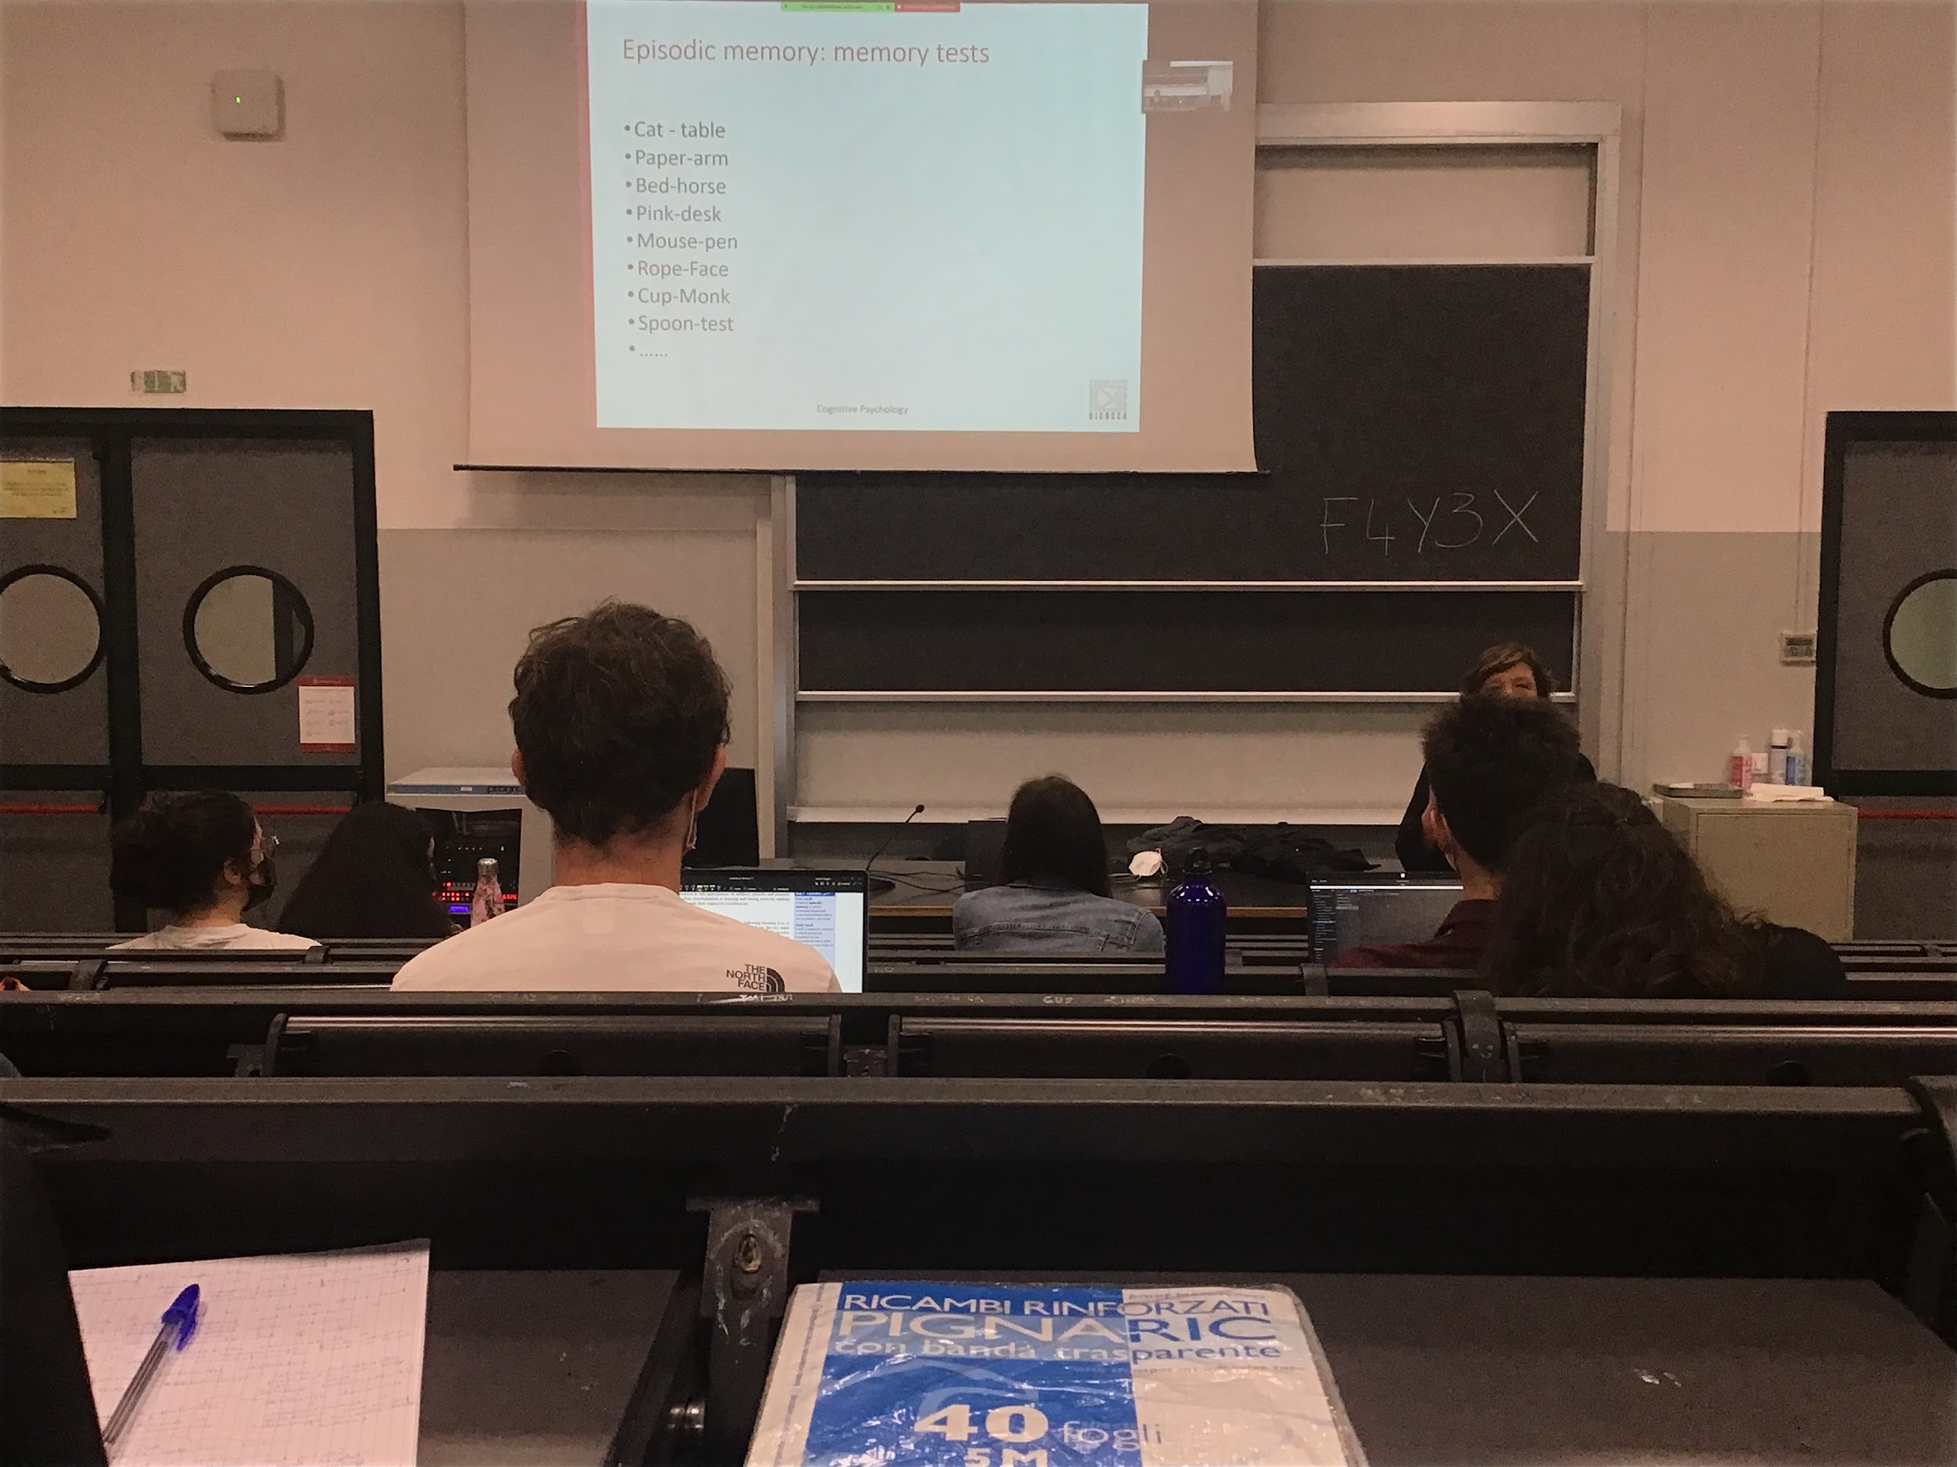

**Test episodic memory**: test information that is already in my semantic, but ask to memorise a couple of words. Memorise this specific information. This specific information will be tested later (in a few minutes). Different type of test that can be extremely difficult

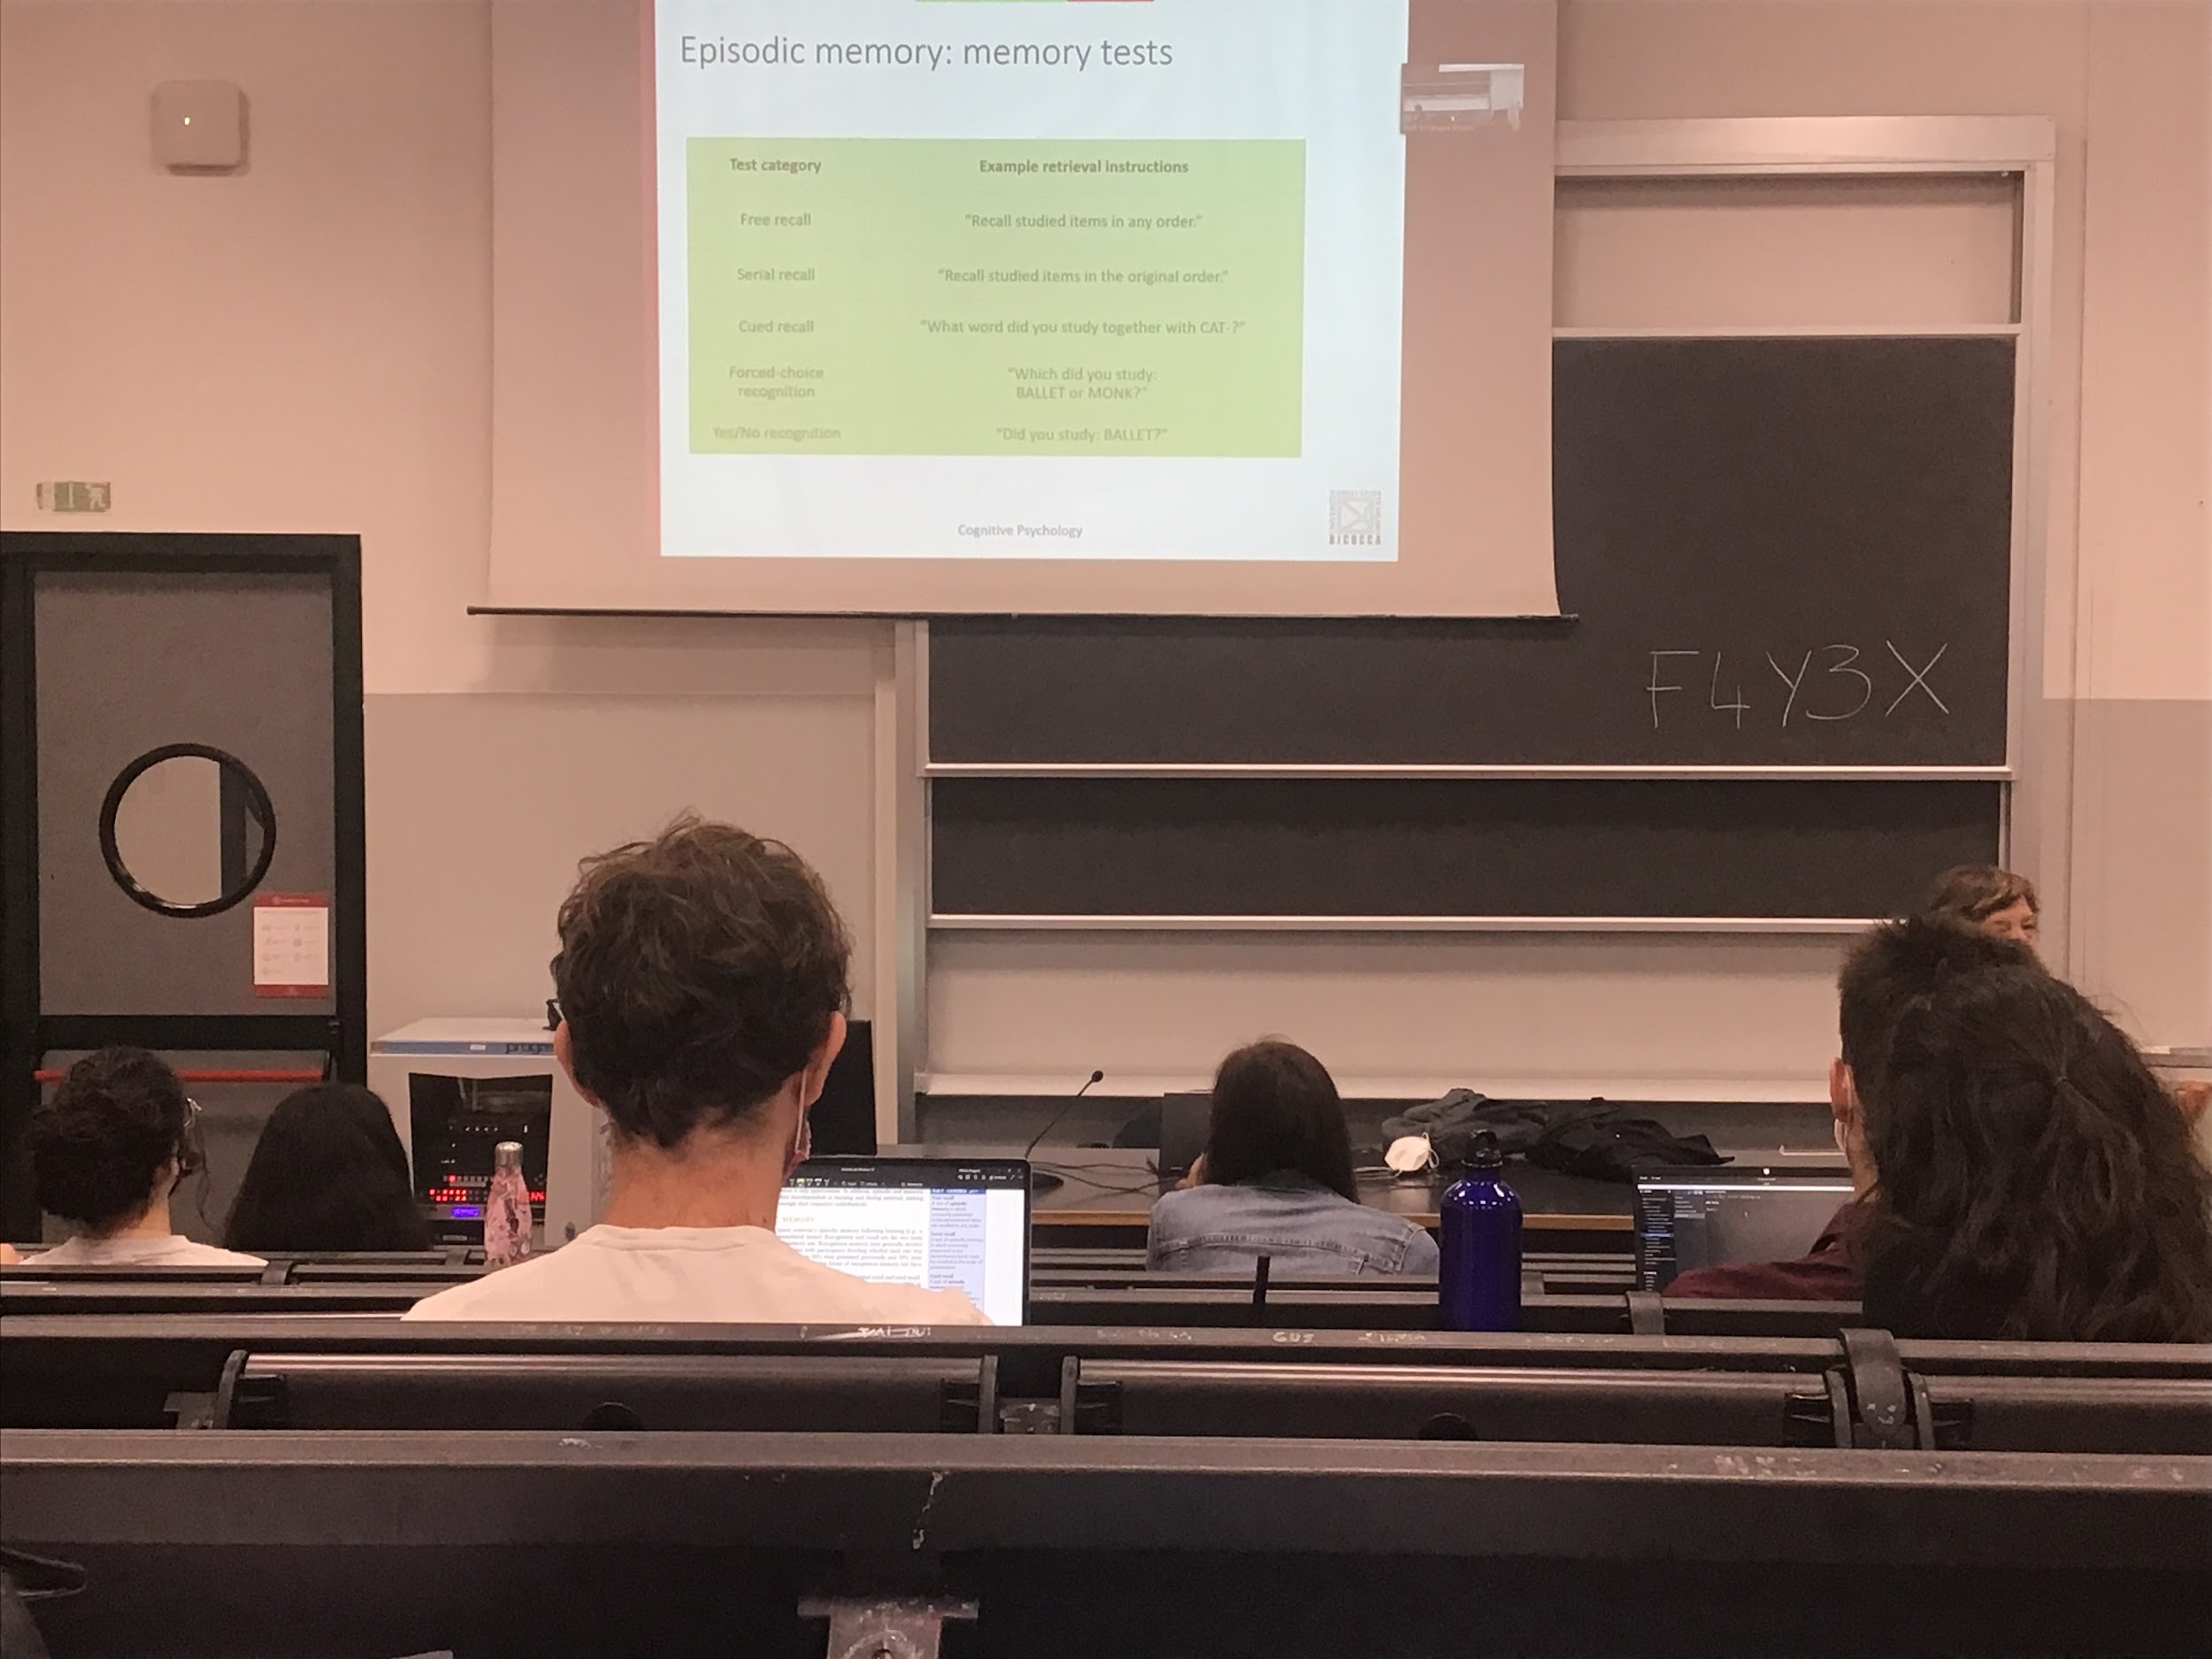

DIfferent memory test:

Recall and recognition

* Recall: want to tell me the words that I presented before
* **Free recall test**: just telling all the words you know, is not extremely easy. Will never remember all the 20 words.
* **Serial recall**: more difficult to tell the words in precise order you have seen them.
* **Cued recall**: easier time of recall, give suggestion, give some cue to be able to extract from memory the other memory
* Recognition: I show one possible response and you tell if that was there or not, it is easier because I give you the answer
* **Forced choice recognition**: give two and select the one that was in the list
* **yes/no recognition**: tell if a specific word was or was not in the list

Most of the time what you don’t recall you can still recognize

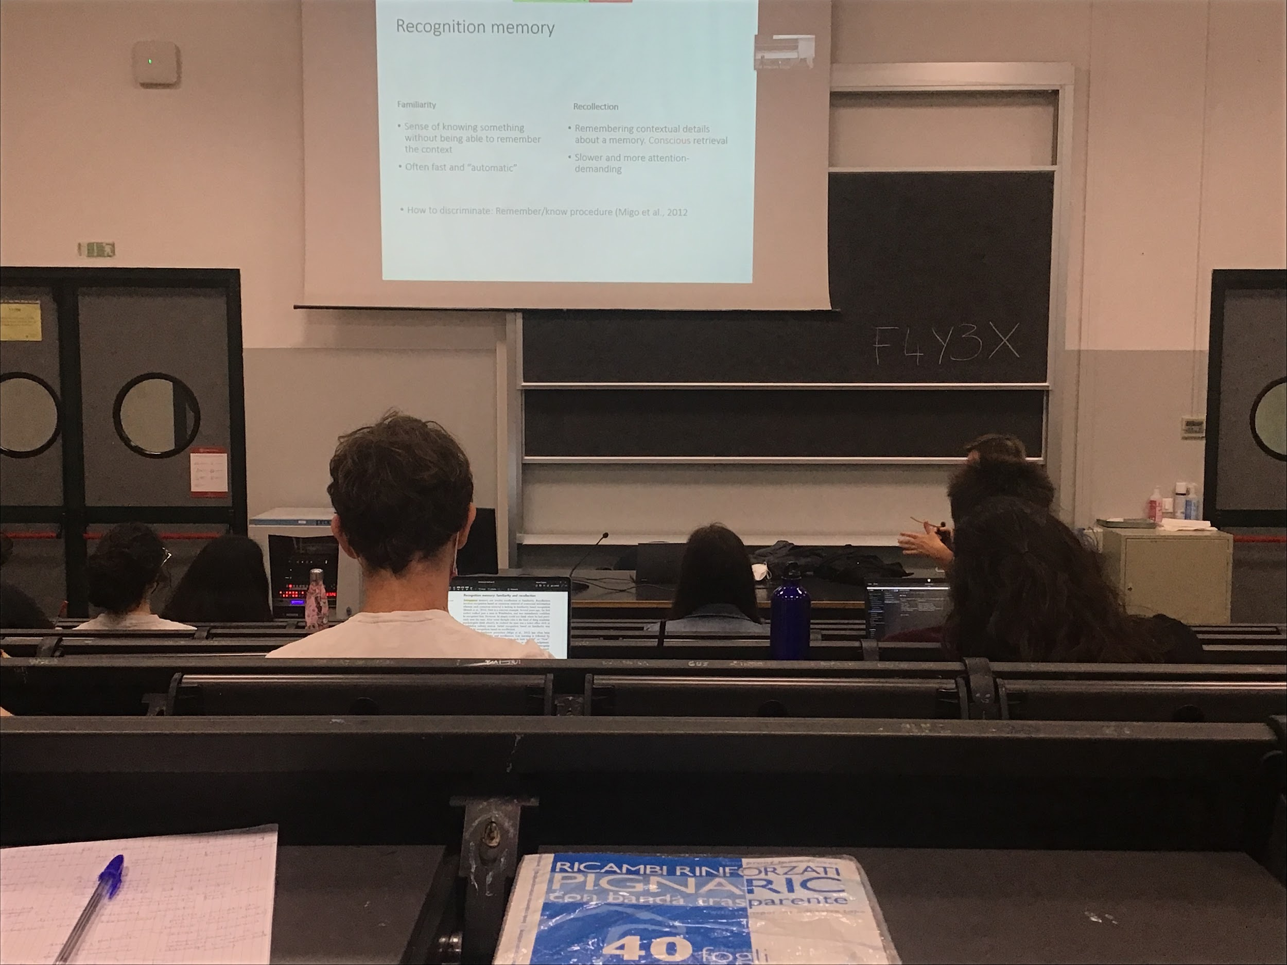

If I write the word “monk” and ask if was there, we can discriminate between familiarity and recollection

* **Families**: have the feeling that the word was there, not exactly sure but if I have to bet I bet it was there, often fast and automatic
* **Recollection**: do remember that the word was there. Clear representation of the word. Remember even the word that was associated with, or the column or the position… I can consciously retrieve the information. It is slower and you have to focus a little more

To discriminate between familiarity and recollection is to use the **remember-know-procedure**

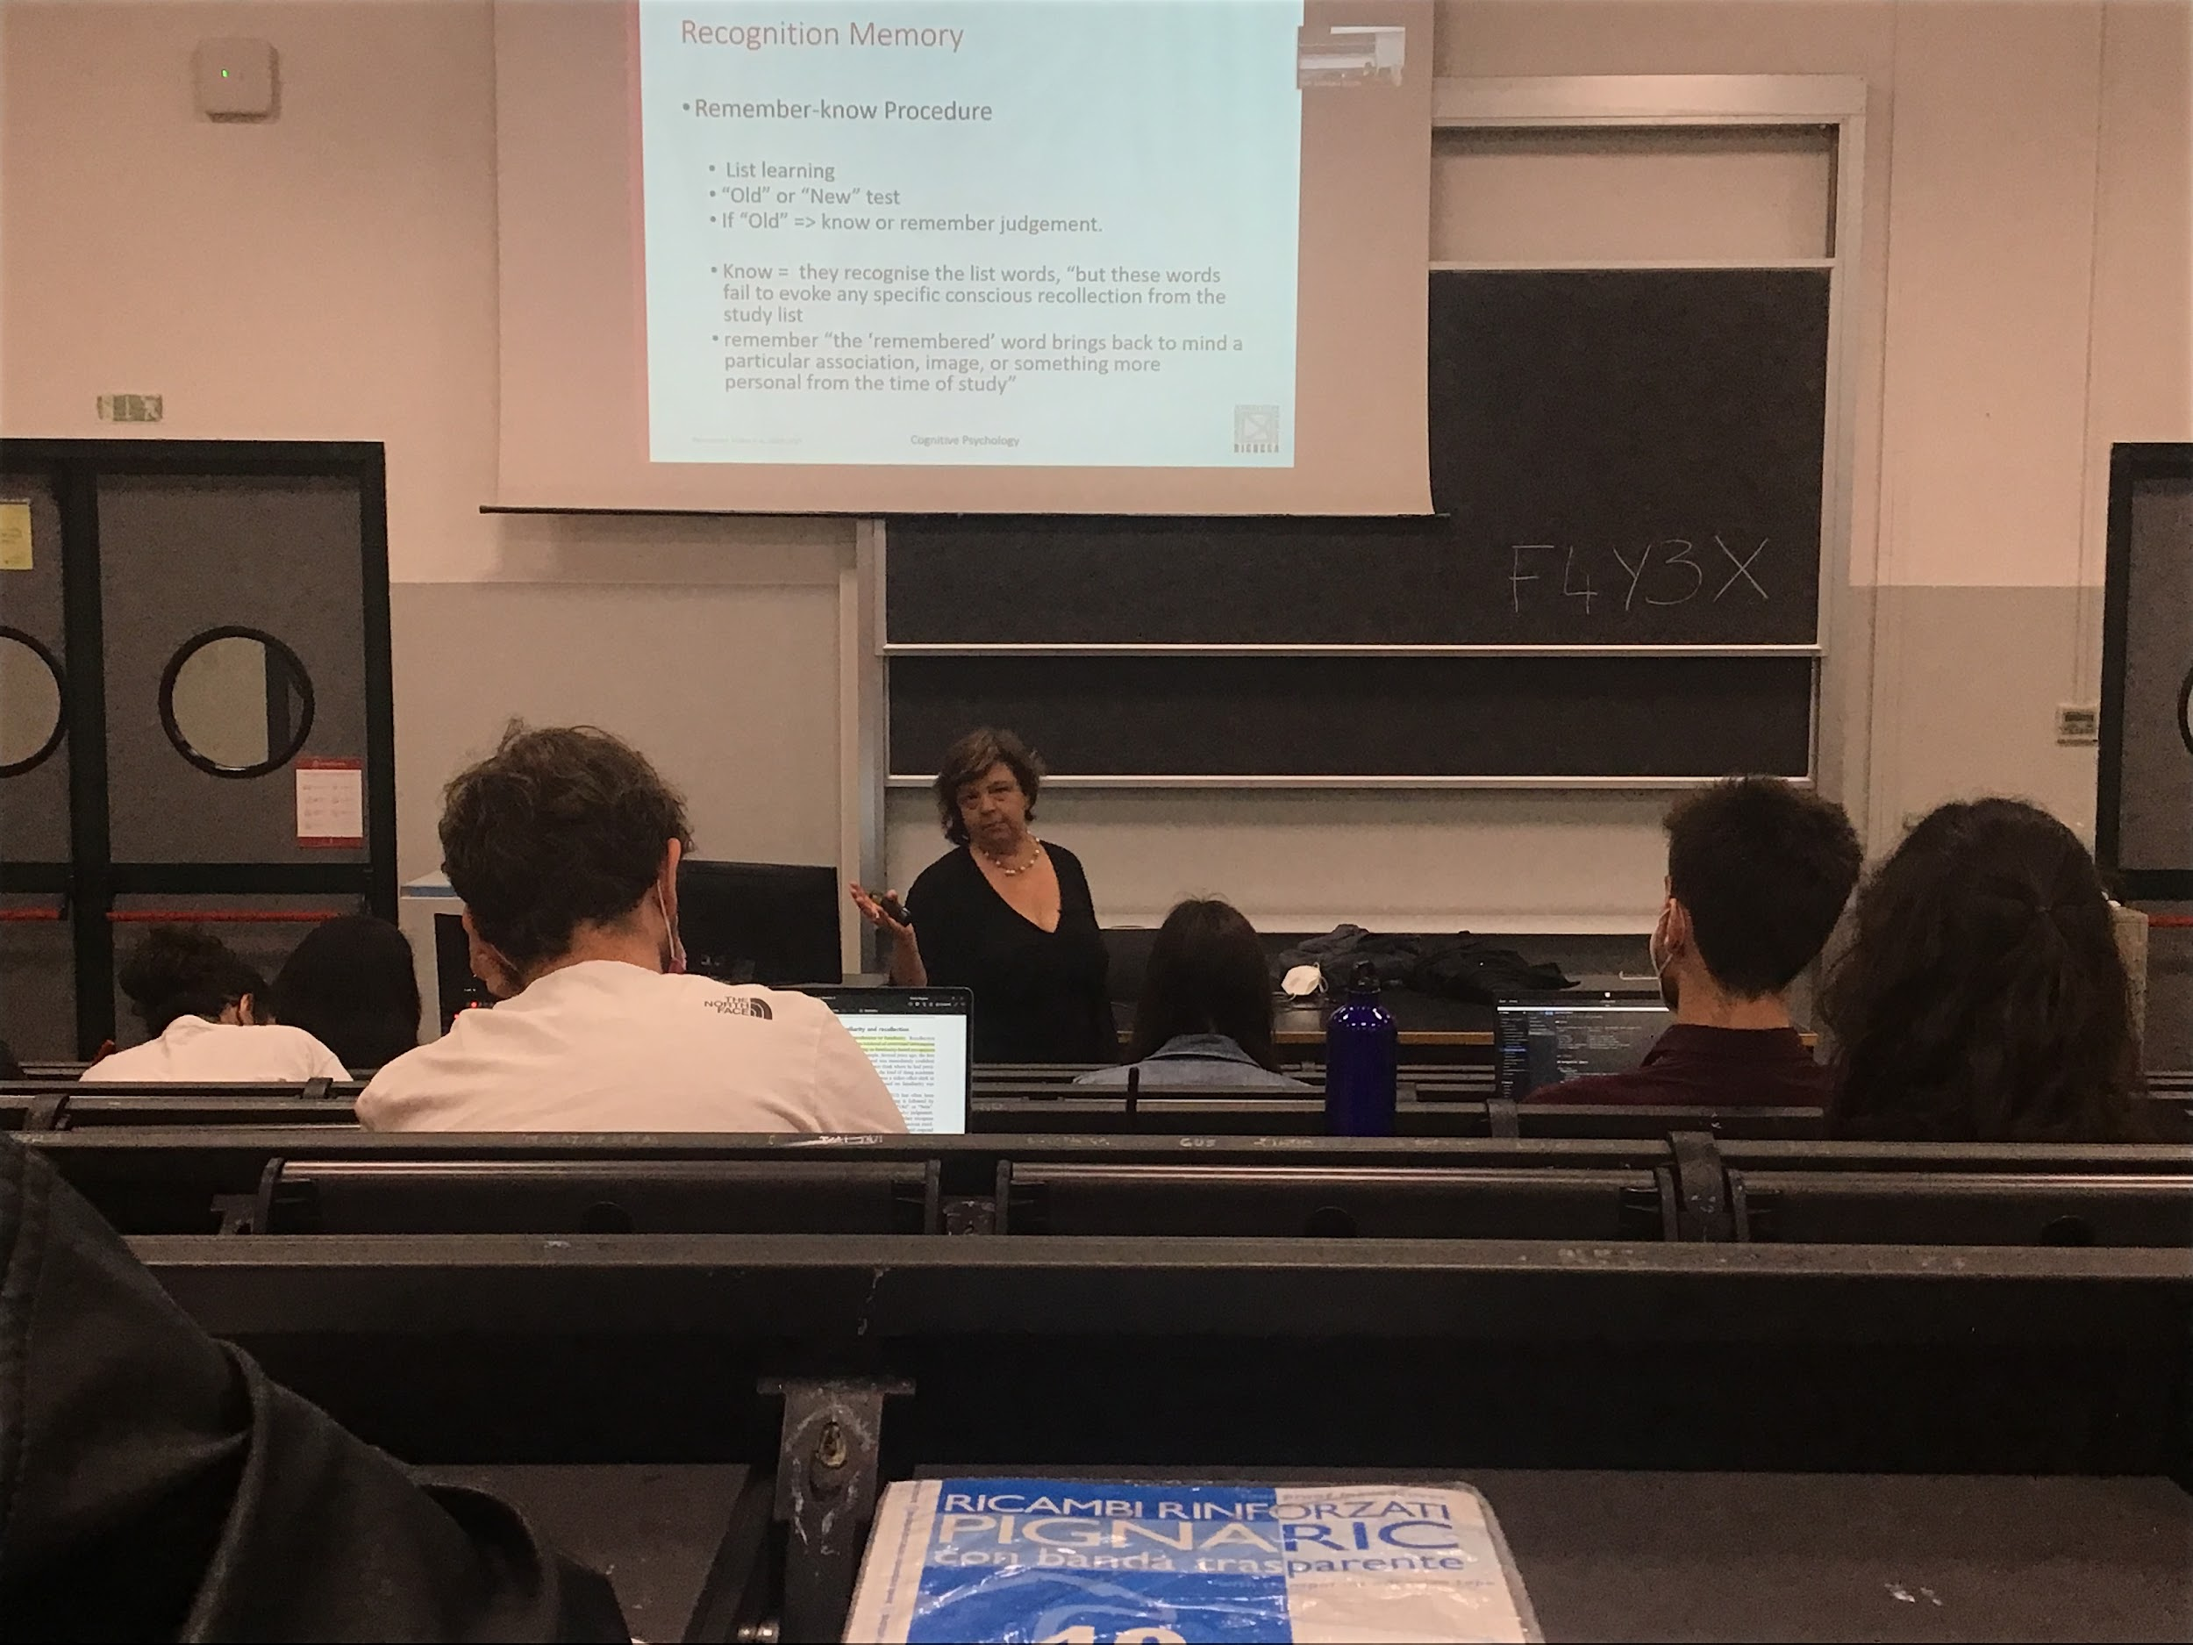

Show I list of words, then I show one word at the time. 50% of the time was a word not in the list, 50% was in the list.

Answer yes or no if the word was in the list or not. If you say yes you have to tell if you know if or if you remember it, do you have a clear recollection or is it just familiarity?

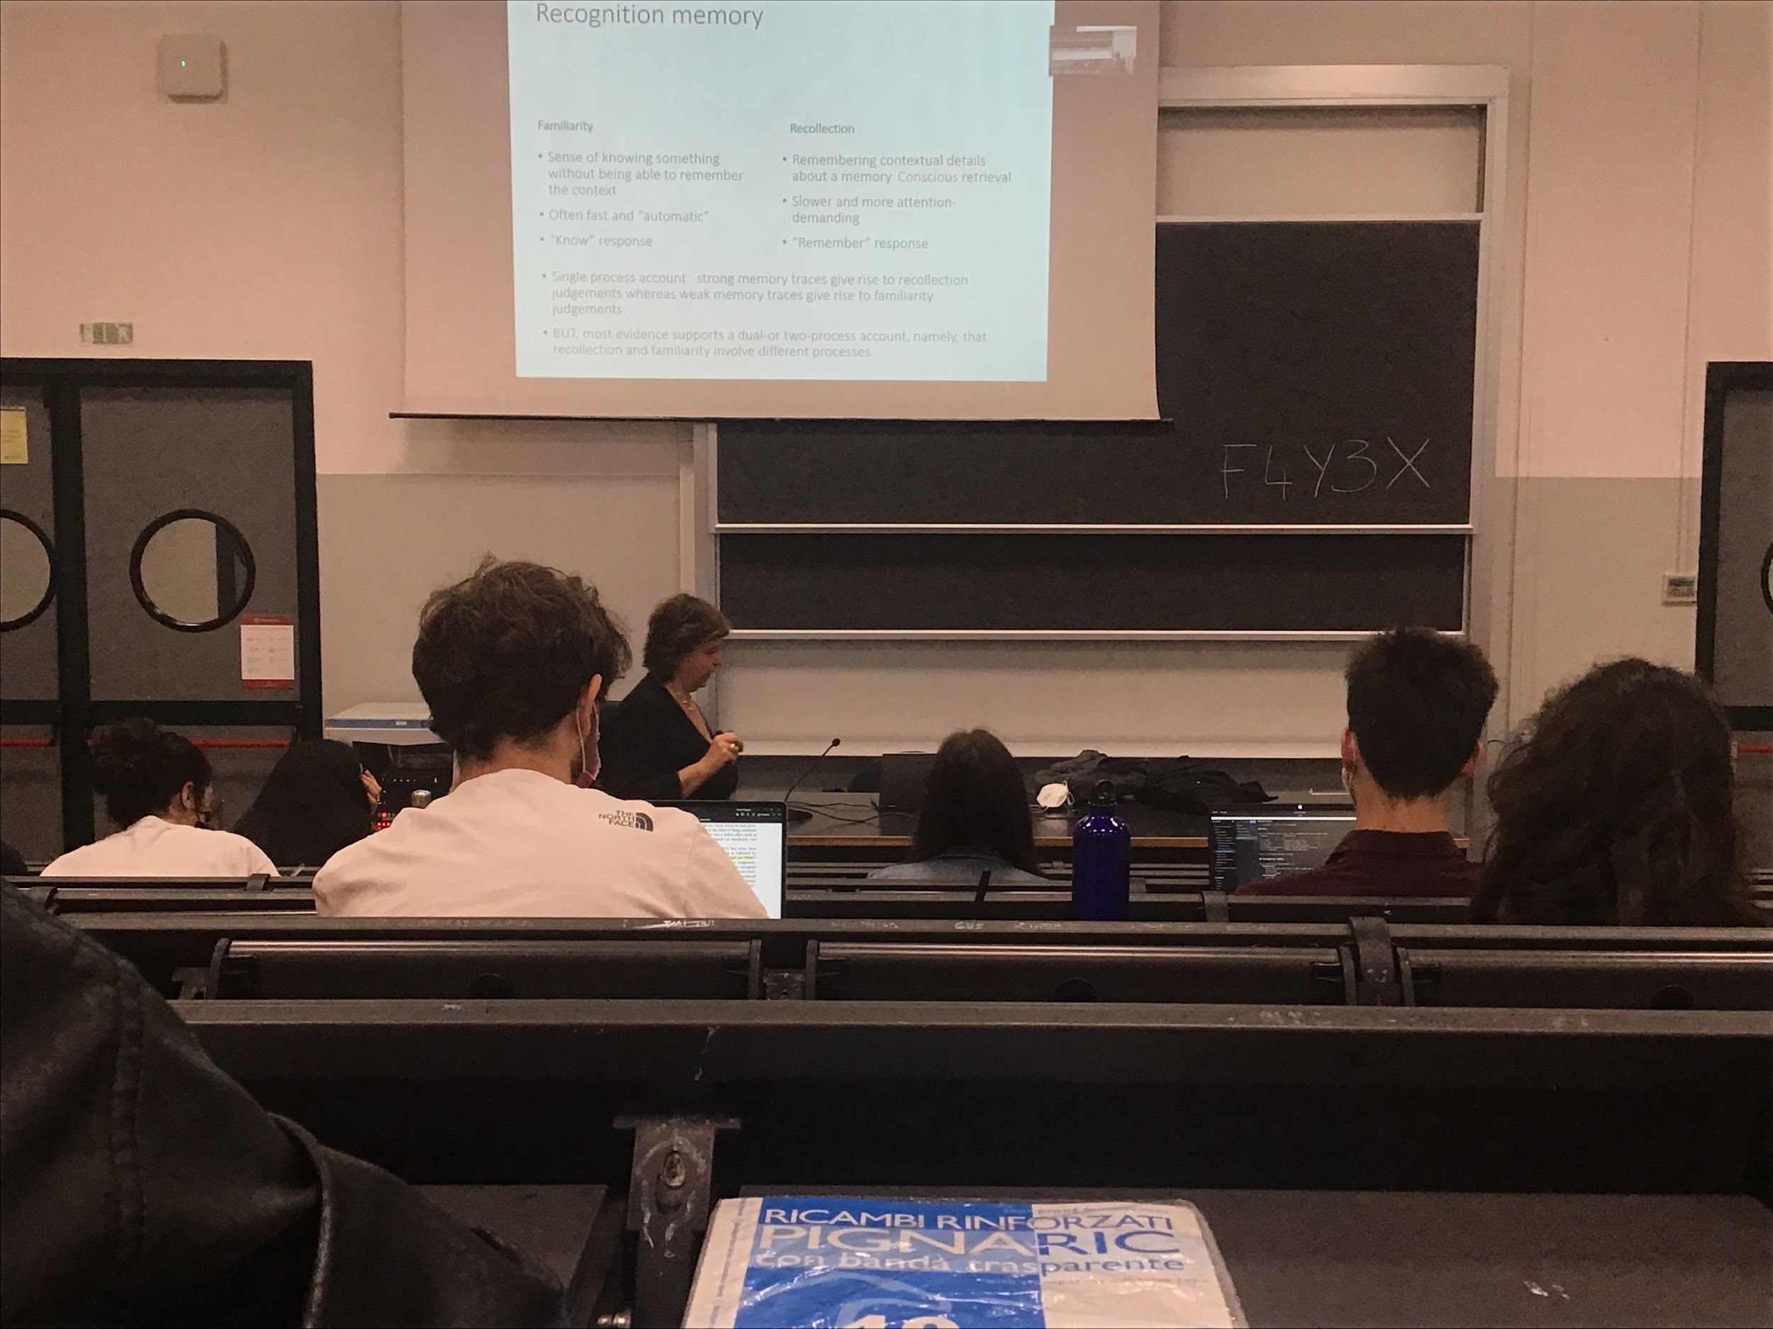

Familiarity and recollection are discriminated behaviourally with the remember-know-paradigm

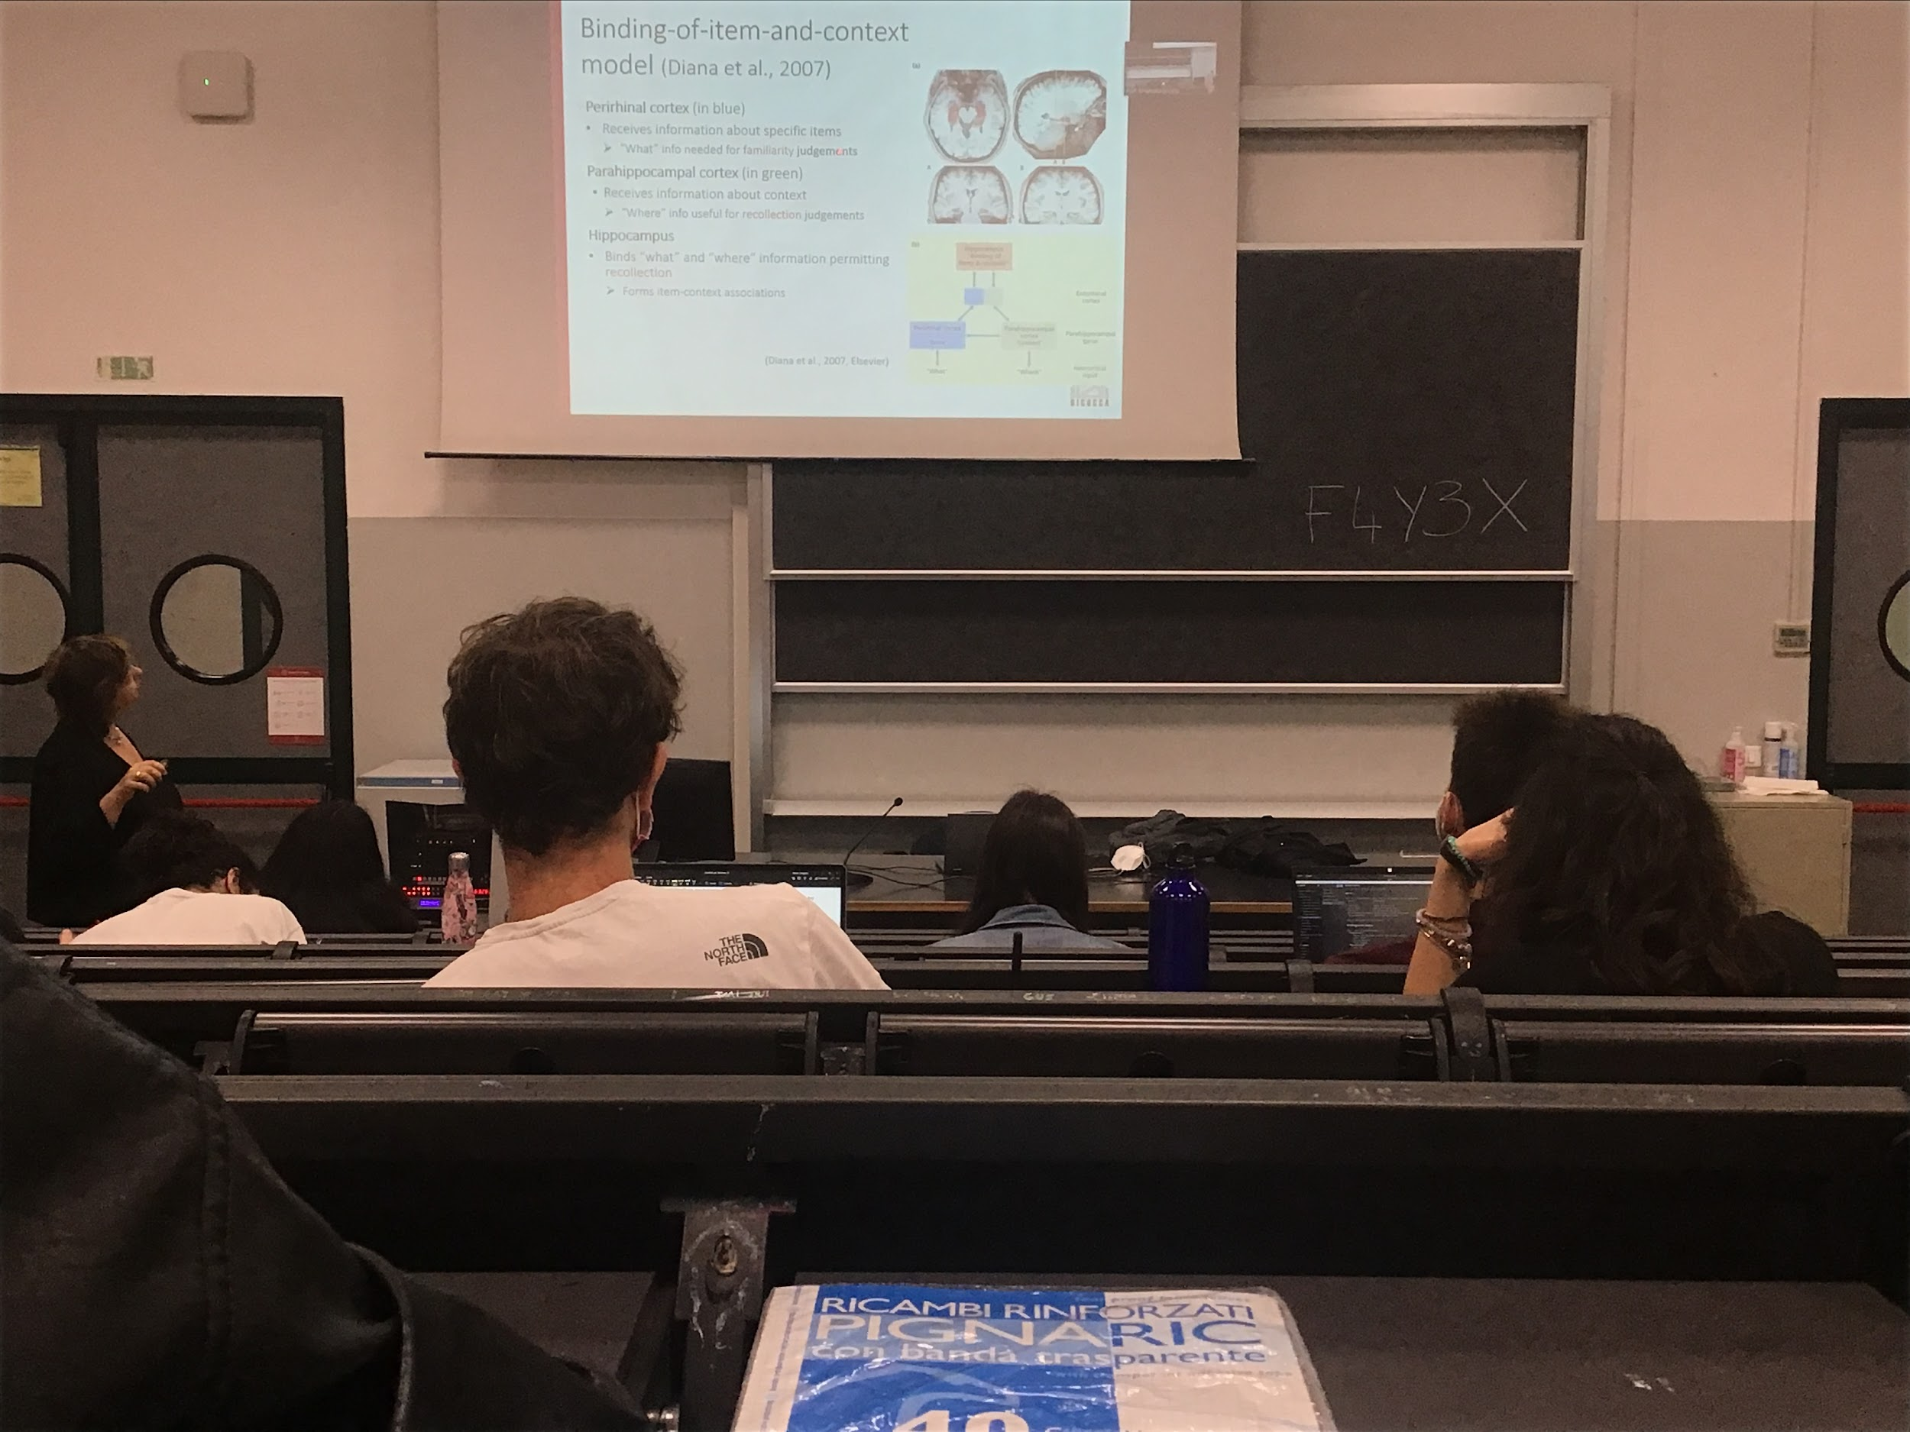

most evidence support the idea of two different process that actually different areas of the brain are active when we are familiar with some information or when we are recollecting

Different areas

This model tries to explain how recognition memory works in the episodic memory. States that there are different areas of the brain active when we are familiar with an object or when we recollect some object. Different areas active in different situation

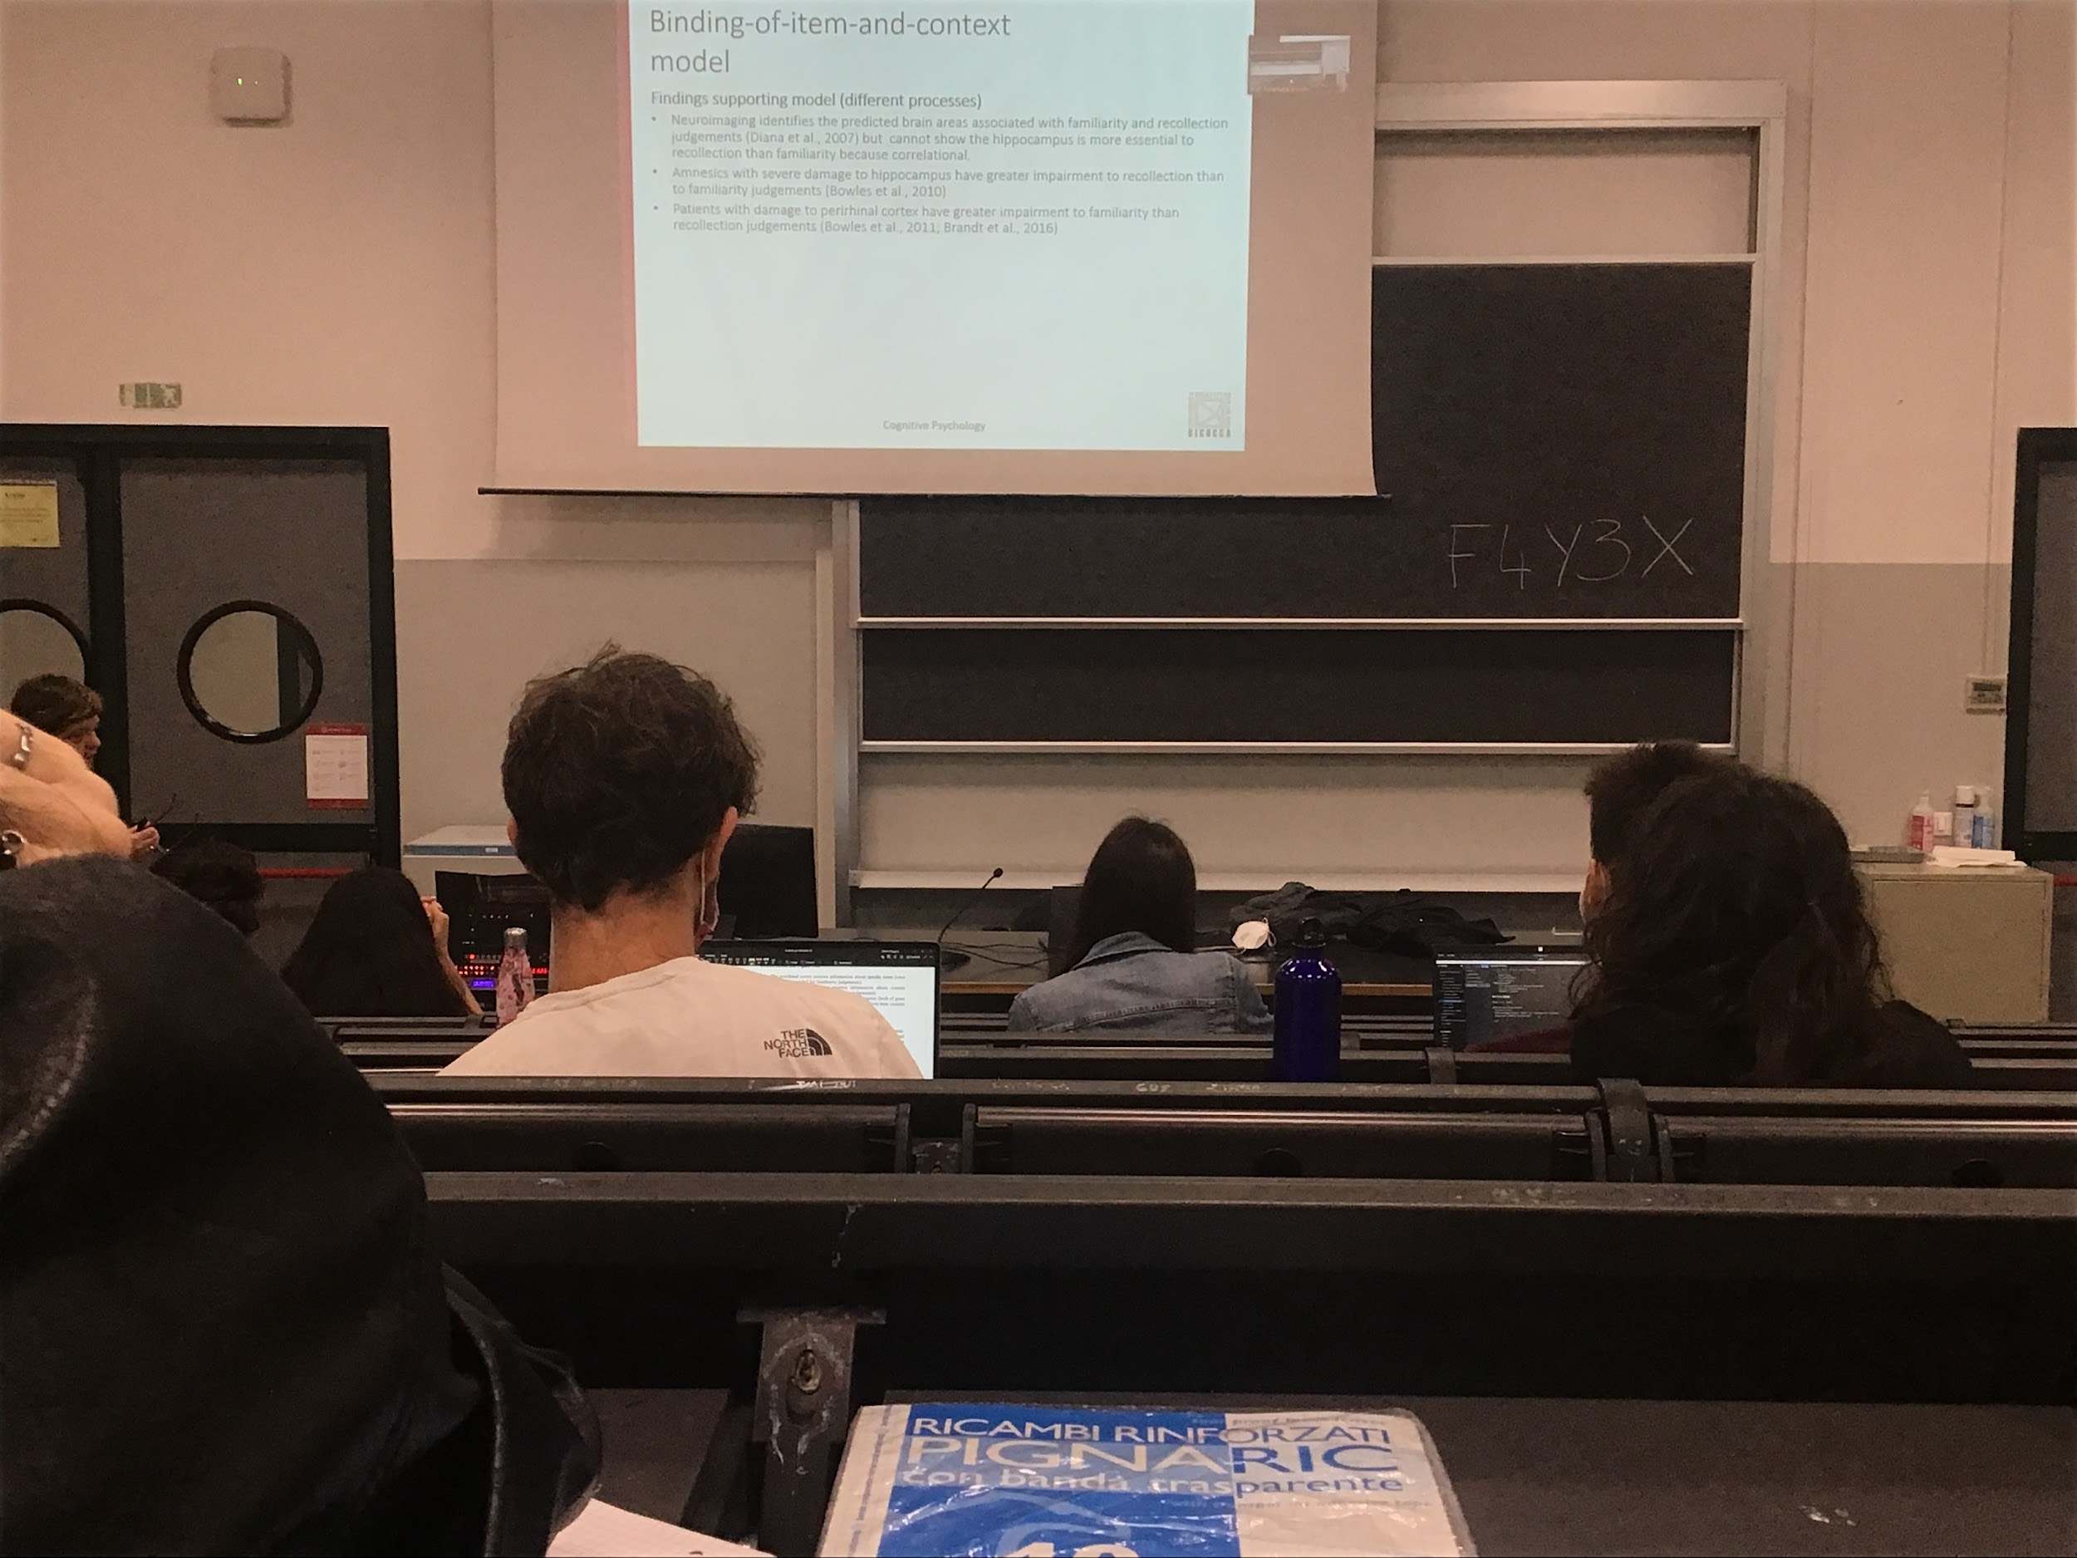

There is support for this model but there are some doubts

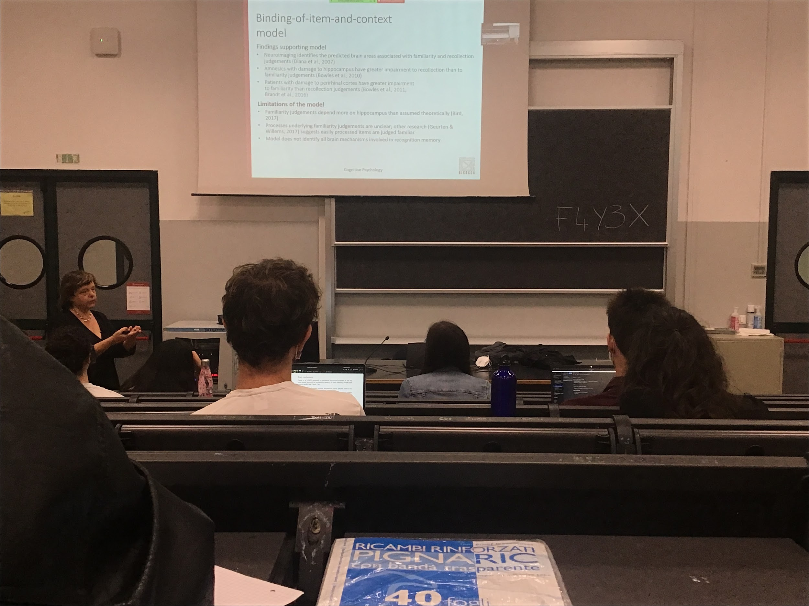

Different types of recognition

## Audio 2

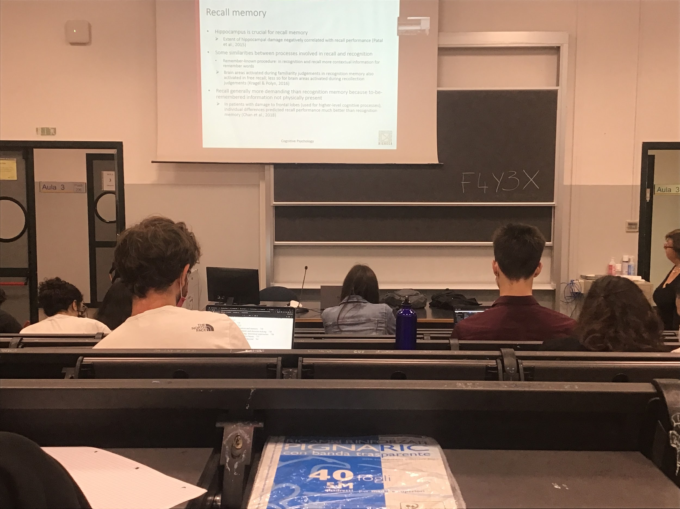

When I do not show you an item and ask if you saw that item before or not. Just ask you to try to take our from memory the information that presented earlier

Hippocampus is important for recalling memory. With a larger hippocampus lesion recall becomes very difficult

Similarly between recall and recognition, brain areas activated during familiarity are also active in free recall. More similar to free recall, less similar to recollection judgement

Actually we make a lot of errors

Why it is so difficult, why do we make so many errors, memory (not only episodic memory) is reconstructive, the system is not build to reproduce exactly what we have seen or heard

The system is made to save for long time only the sense (the gist) of the information

When you reproduce your episodic memory you have some original information and you add details that you have lost

Everytime you repeat an event that you have been into, you change in your mind, every time you repeat it you focus on different details and you end up believing yourself that was something different

When telling an event that you attended with a friend you don’t have the same recollection. Both remember different details

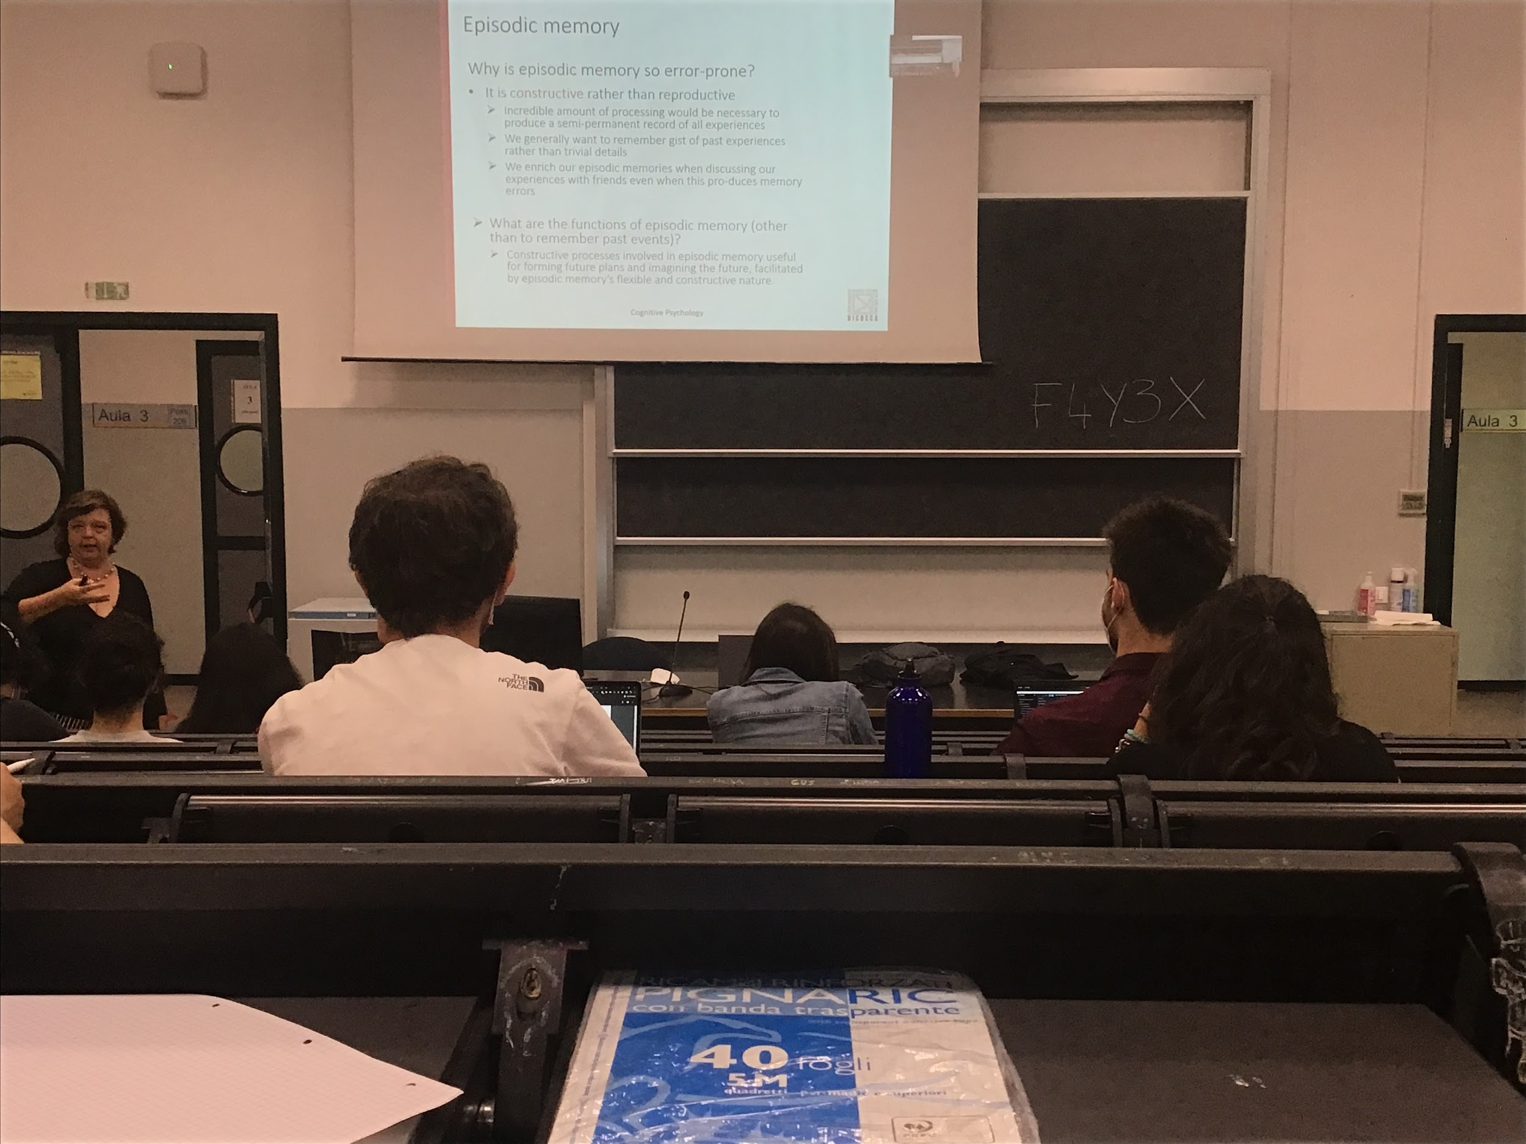

Episodic memory is error prone, we make mistakes and the system does not save the details. We save information that enables us to recostrounct when we talk about the same episode.

Episodic memory does not only allow to remember past event but very useful to save general structure, to be able to process the future

**Episodic memory help us form future plans**, if we save all the details it would be very difficult to plan for the future, need to be more flexible to plan, the situation change a little bit every day, fundamental keep only the important information

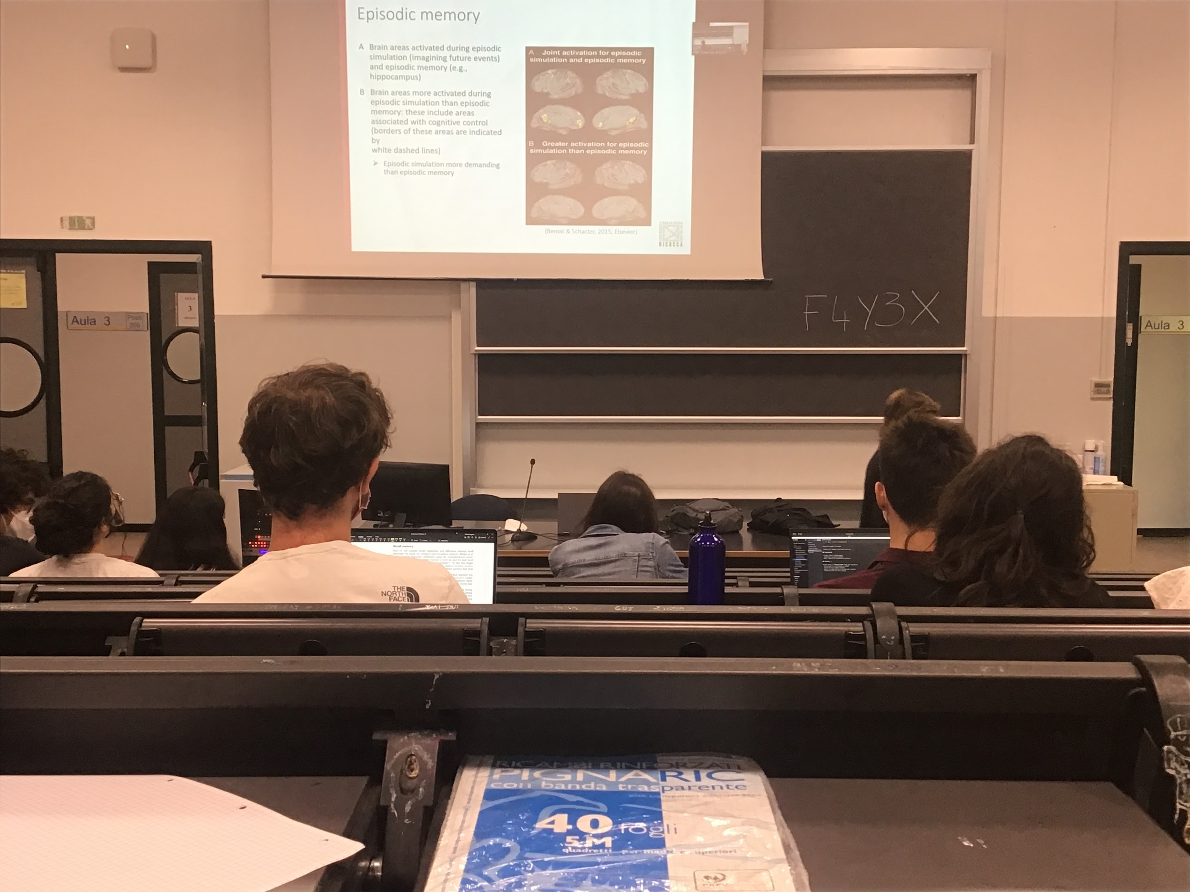

Simulation for the future is prospective memory activates the same types of areas of the brain. Greater activation for the simulation than the episodic memory because you need to be more flexible and open than a single event

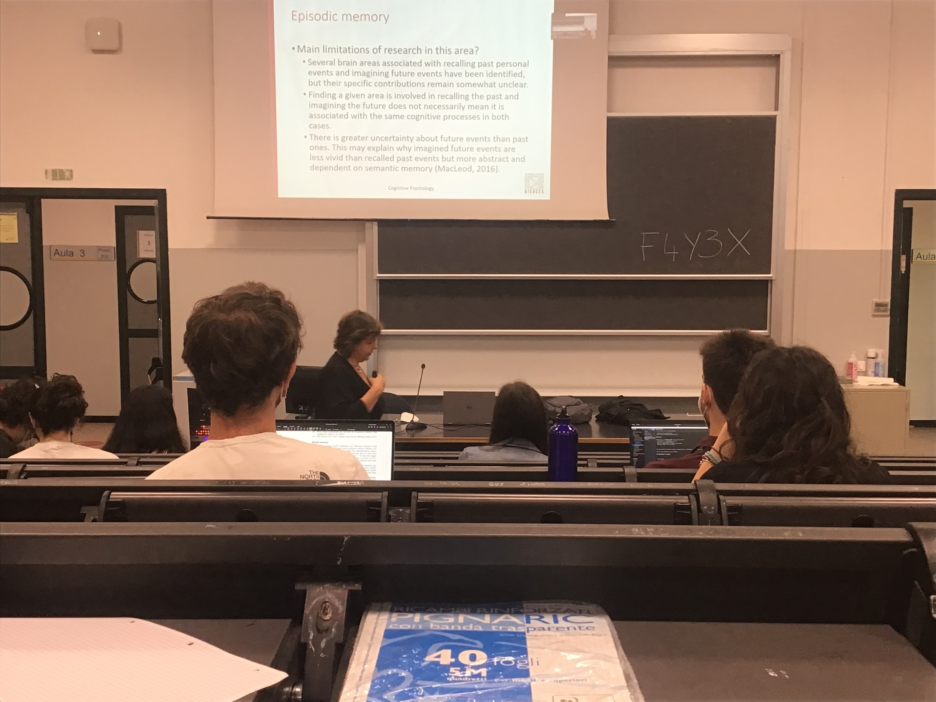

There are different areas underline different types of episodic memory

Not clear what these areas do, we do find the same inactivity in recalling the past and imagining the future. These two tasks are using the same brain areas, but does not mean they have identical process

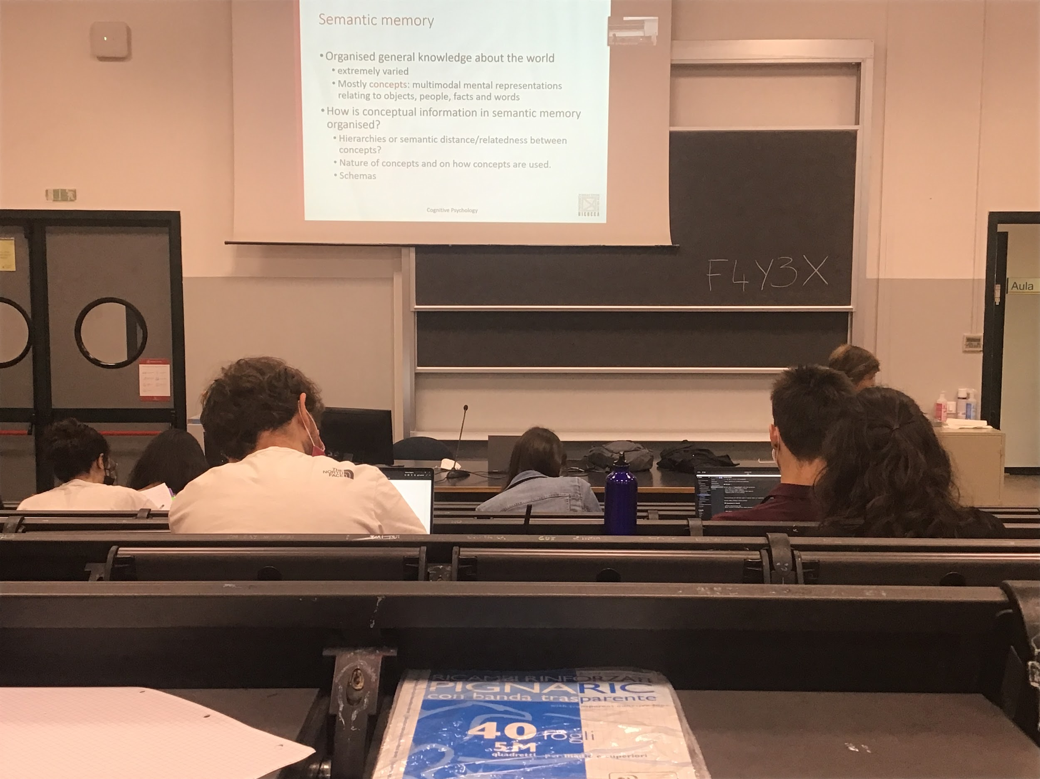

Semantic memory different type of information, not related to (what), where, when (the 3 W). This information is organised, stored in the brain with some criteria. Not just randomly inserted there. The information that we store is incredibly vast

Not only simple concept but also more complex information

Evey time of structural information that helps us doing some kind of task: how it is organised

If I ask you to remember a series of information you try to organise it first. Randomly mixing all the slides is difficult, you need organisation. What kind of organisation does the system use?

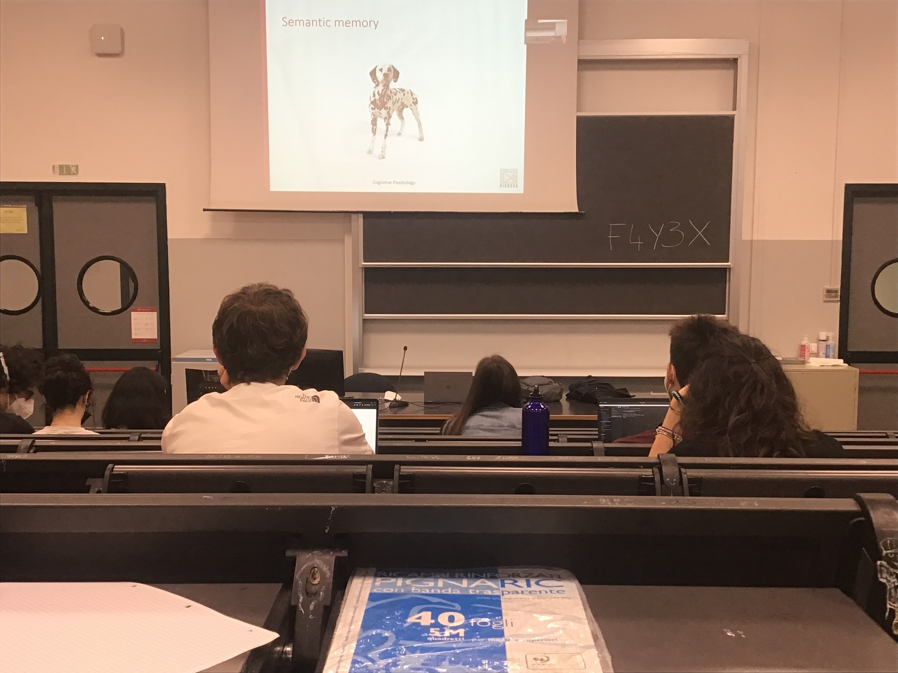

What is this? 3 possible responses

Is a dog, animal, Dalmatian

Most of the time we answer with the more general

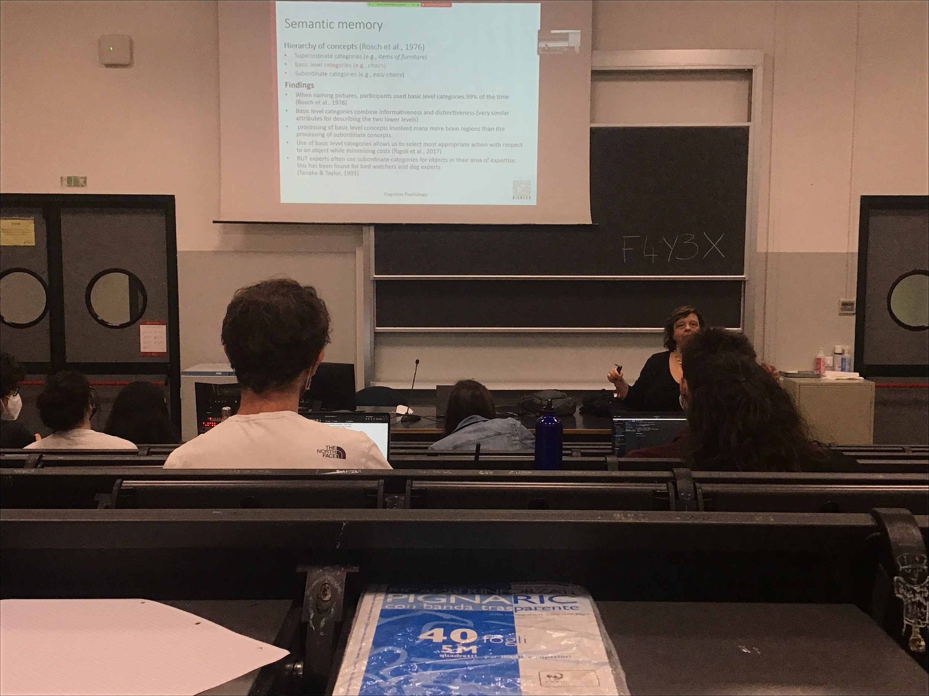

When we consider concepts we have to consider that there is a hierarchy. The same identification object can be classified in different types

* Basic level categories: dog, chair…
* Superordinate categories: animal, fortinure
* Subordinate categories: dalmatian, easy chair

Since people’s classification follow these 3 categories it is possible this is the way our brain organises information

Usually automatically go the basic level

When I give you a lot of different images to name you use the basic level categories. But if I show only different species of dog than you go in the subordinate category, you fell strange answering only *dog, dog, dog* so you tell the species

Usually automatically we go to the basic level. The basic categories are the most interesting, they give more information (if I say *I see an animal* it is too general, can be a dog, a moshito, an elephant…) and it enables us to discriminate. You would have more information with subordinates (*I see a corgie* (specie of dog) gives more information than *I see a dog*), but if you ask the characteristics of a dog the only difference is the colour of the fur.

There are exceptions: if I do the same task with dog expert they never say dog but tell the species. For the dog expert the dogs are not the same

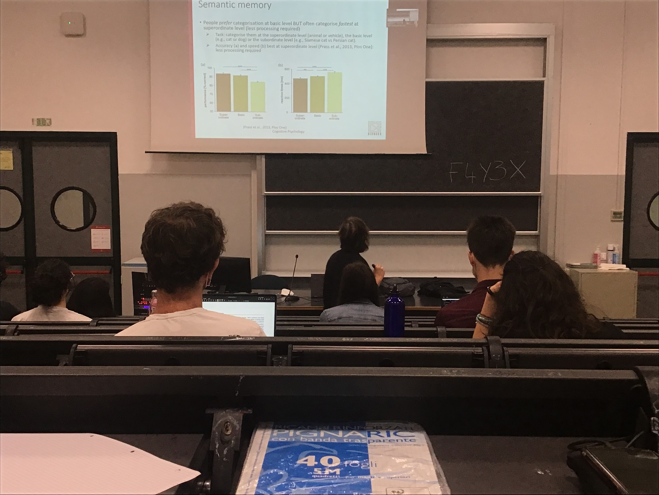

Much easier to categorise the superordinate (and much faster) that when you have to say dog with respect to animal

You prefer the basic but you are much better at the superordinate support the idea of **hierarchy** and that there is a **structure organisation in the semantic memory**

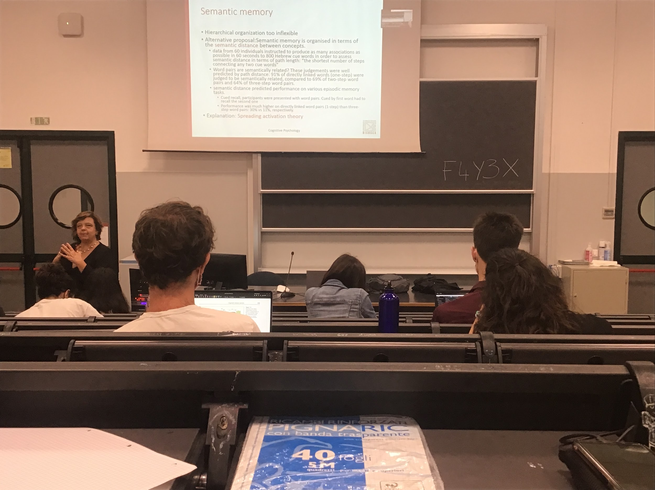

This theory is very strict: but sometimes there are strange animals that we take much longer.

The second approach has to how semantic memory is organised is that is not hierarchical, close by information is related in some way semantically

In your memory organisation you have the concept of dog that is close to Dalmatia and also close to cat (even if is not the same animal is very frequent)

The way you organise information in memory is to store close by information that you think have some connections. **Semantic memory is organised in terms of the semantic distance between two concepts.**

**Experiment**: I give you 1 minute, say all the words that come out in your mind related to the word that I give you.

Semantically close, in my representation dog and cat are very close, more two concepts have in common closer they are

You **remember much better cat-dog than cat-table**

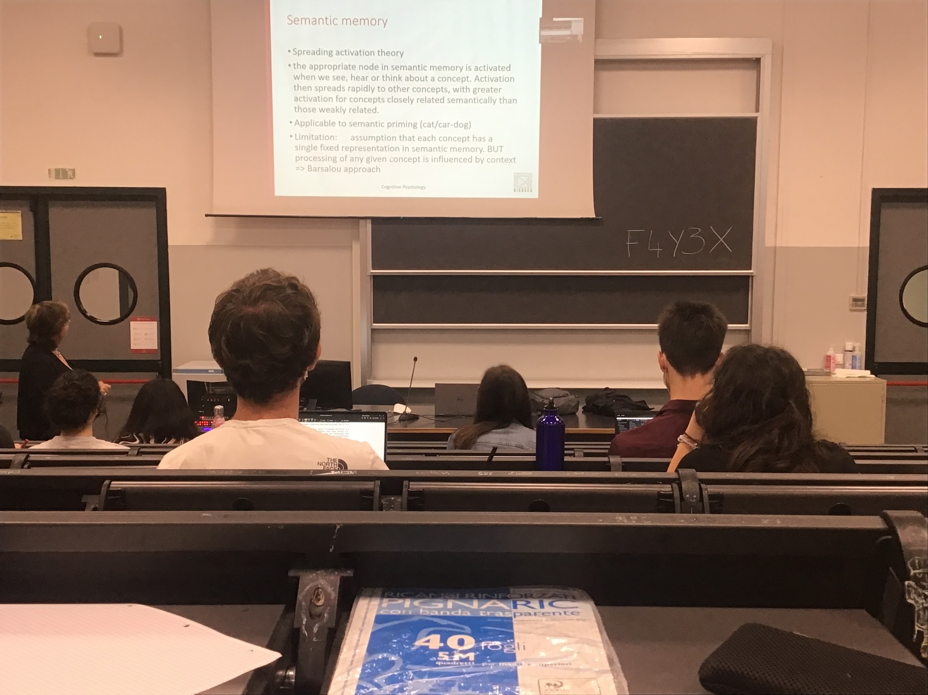

**Spreading activation theory**: in memory there are a lot of nodes, each concept is a node, and it is connected to some different concepts. When I activate the node cat I do not only activate a single node but also the connection to the close by nodes, spreading of activation through the network

The task of priming, show two words and have to tell if the 2 words are an animal. If I give you dog-cat and door-cat you are faster in the first, the first word activate all the nodes near by, so the node is already active and is easier to retrieve information

1 thing that it does not explain is the fact that what we hear or see we don’t see object in isolation, see objects in different concepts